Colon Cancer Detection Using Deep Learning Techniques

By
MAHMUDUL HASAN
0242220005101339

FINAL YEAR DESIGN PROJECT REPORT
This Report Presented in Partial Fulfillment of the Requirements for the Degree of Bachelor of Science in Computer Science and Engineering

Supervised by
Dr. Naznin Sultana
Associate Professor
Department of Computer Science and Engineering
Daffodil International University

Co-Supervised by
Dewan Mamun Raza
Senior Lecturer
Department of Computer Science and Engineering
Daffodil International University



DAFFODIL INTERNATIONAL UNIVERSITY
Dhaka, Bangladesh
June 29, 2026
©Daffodil International University

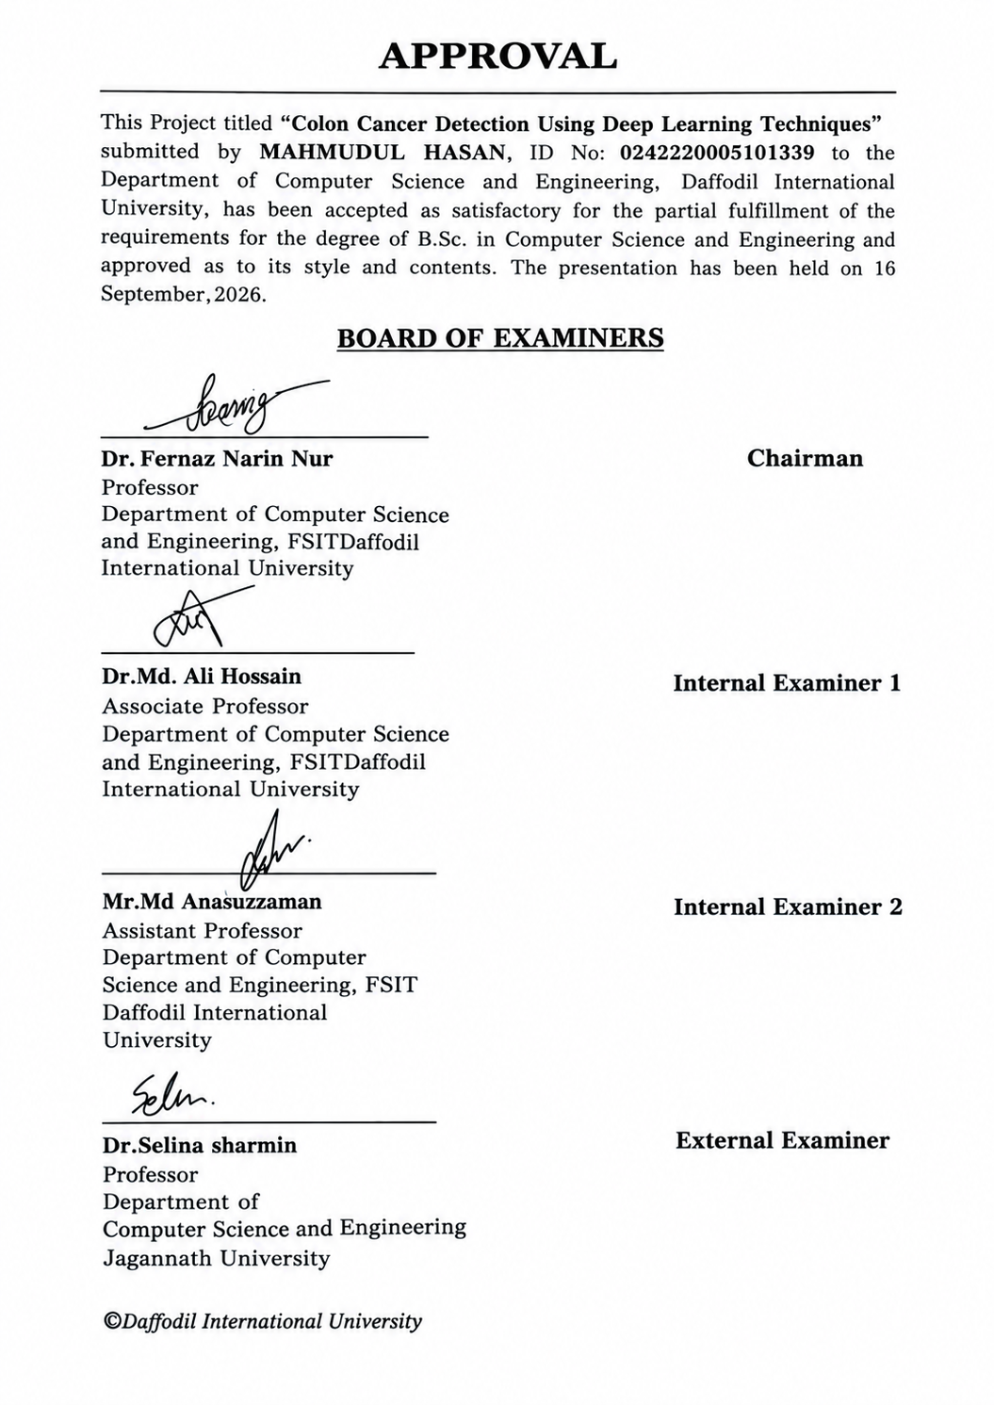

ACKNOWLEDGEMENTS

This work would not have been possible without the support and contributions of many individuals over the past two semesters. We are deeply grateful to everyone who has as- sisted us in one way or another.

First, we express our heartfelt thanks and gratefulness to the almighty for His divine blessing making it possible for us to complete the Final Year Design Project(FYDP) successfully.

We are grateful and wish our profound indebtedness to Dr. Naznin Sultana, Associate Professor, Department of Computer Science and Engineering, Daffodil International University, Dhaka, Bangladesh. Deep knowledge and keen interest of our supervisor in the field of Deep Learning to carry out this project. His endless pa- tience, scholarly guidance, continual encouragement, constant and energetic supervision, constructive criticism, valuable advice, reading many inferior drafts, and correcting them at all stages have made it possible to complete this project.

We would like to express our heartfelt gratitude to the Head of the Department of Com- puter Science and Engineering, for his kind help in finishing our project and also to other faculty members and the staff of the Department of Computer Science and Engineering, Daffodil International University.

We would like to thank our entire course-mates at Daffodil International University, who took part in this discussion while completing the coursework.

Finally, we must acknowledge with due respect the constant support and patience of our parents.

ABSTRACT

Colorectal cancer remains one of the most fatal malignancies of the human digestive tract, where early and accurate detection directly dictates survival rates. Traditional diagnosis rests on microscopic evaluation of tissue biopsies by pathologists. However, this manual approach is time-intensive, requires extensive specialized knowledge, and often suffers from inter-observer variability. To alleviate these operational bottlenecks, we developed a deep learning framework designed to automatically differentiate between malignant and benign colon histopathology images.
Our study utilized a dataset of 10,000 labeled tissue images, categorized into cancerous and non-cancerous classes. To safeguard evaluation integrity and eliminate data leakage, the dataset was split into training, validation, and test sets using a strict 70:15:15 ratio prior to any pre-processing steps. Each image was then enhanced via Contrast Limited Adaptive Histogram Equalization (CLAHE) to boost local contrast, followed by resizing and data augmentation to improve generalization.
The core architecture uses a dual-branch hybrid design. One branch comprises a custom Convolutional Neural Network (CNN) tailored to extract fine-grained local textures. The second branch leverages a VGG16 model pre-trained on ImageNet to supply broader, transfer-learned spatial representations.
During evaluation, the combined architecture reached a overall test accuracy of 96.60% and an AUC-ROC of 0.9996. Crucially, the model recorded a 100% recall rate for malignant samples, ensuring no true positive cases were overlooked. For model interpretability, we applied Grad-CAM visualization to map decision-making regions. The attention heatmaps confirmed that the network relied on clinically relevant structures—such as glandular disorganization and abnormal nuclear clusters—rather than superficial background noise. Overall, these findings demonstrate that our hybrid pipeline can serve as a dependable clinical decision support system, helping pathologists streamline colon tissue screening while reducing diagnostic discrepancy.

Table of Contents

Approval i

Declaration ii
Acknowledgements iii
Abstract iv
List of Figures vii
List of Tables viii
- Introduction 1
  - Introduction 1
  - Motivation 1
  - Objectives 1
  - Methodology 1
  - Project Outcome 1
  - Organization of the Report 1
- Background 2
  - Introduction 2
  - Literature Review 2
    - Similar Applications 3
  - Gap Analysis 3
  - Summary 3
- Research Methodology 4
  - Methodology/Requirement Analysis & Design Specification 4
    - Overview 4
    - Proposed Methodology/ System Design 4
    - Functional and Nonfunctional Requirements 5
    - Data Flow Diagram 5
    - UI Design 5
  - Detailed Methodology and Design 5
  - Project Plan 5
  - Task Allocation 5
  - Summary 5
- Implementation and Results 6
  - Environment Setup 6
  - Testing and Evaluation/Performance/ Comparative Analysis 6
  - Results and Discussion 6
  - Summary 6
- Engineering Standards and Design Challenges 7
  - Compliance with the Standards 7
    - Software Standards 7
    - Hardware Standards 7
    - Communication Standards 7
  - Impact on Society, Environment and Sustainability 7
    - Impact on Life 7
    - Impact on Society & Environment 7
    - Ethical Aspects 7
    - Sustainability Plan 7
  - Project Management and Financial Analysis 7
  - Complex Engineering Problem 8
    - Complex Problem Solving 8
    - Engineering Activities 8
  - Summary 8
- Conclusion 10
  - Summary 10
  - Limitation 10
  - Future Work 10
References 11

List of Figures

3.1 This is a sample diagram……………………………………………………..4

3.2 Figure 3.1: proposed Methodology Flow ….…………………………………..11

3.3 Figure 3.2: proposed Hybrid CNN+VGG16 Model Architecture ….…….12

3.4 Figure 3.3: Data Floe Diagram……………………………………………....…14

3.5 Figure 3.3: UI Design……………………………………………………….……15

3.6 Figure 4.1: Summary of the Proposed Hybrid Model …………………...….19

3.7 Figure 4.2: Hybrid Model Training………………………………………...….20

3.8 Figure 4.2: Training vs. Validation Accuracy and Loss Curves……………21

3.9 Figure 4.3: Confusion Matrix of the Proposed Hybrid Model……………….22

3.10 Figure 4.4: Confusion Matrix of the Proposed EfficientNetB0……..…….23

3.11 Figure 4.4: Confusion Matrix of the Proposed RestNet50……………..….24

3.12 Figure 4.4: Grad-CAM Visualizations of Sample Test …………..………..26

3.13 Figure 4.5: Random UI Photo Prediction………………………….…27,28,29

List of Tables

3.1 Table 2.1: Summary of Literature Reviewed…………………4,5,6

3.2 Gap Analysis…………………………………………….…..8

3.3 Project Timeline (Task Allocation)……………………………………..17

3.4 Environment Setup……………..…………………………18

3.5 Confusion Matrix Summary………………………………………..…24,25
3.6 Sample Predictions Generated via the Demonstration ……………..26
3.7 Cost Analysis……………………………………………………………….35
3.8 Complex Problem Solving……………………………..…..36
3.9 Mapping with Knowledge Profile…………………………..………..37,38

Chapter 1

Introduction

This chapter outlines the foundational context of colon cancer diagnosis and explains why deep learning serves as a compelling approach for modern histopathological analysis. It specifies the key project goals, summarizes the methodology used, and highlights the main expected outcomes. Finally, a brief overview of the remaining report structure is provided to guide the reader through subsequent chapters.

Introduction
Colorectal cancer stands among the most prevalent malignancies and remains a primary cause of cancer mortality globaly. Arising in the epithelium of the colon or rectum, early detection is critical; delayed diagnosis often leads to metastasis and sharply declining survival rates. The gold standard for clinical diagnosis continues to be histopathological assessment, where pathologists inspect tissue biopsies under a microscope for cellular abnormalities. Despite its reliability, this manual process is labor-intensive, dependent on high-level expert availability, and prone to subjective variations between practitioners reviewing the same tissue slides.To address these diagnostic constraints, computer-assisted systems leveraging deep learning offer a compelling alternative. Convolutional Neural Networks (CNNs) have shown strong capabilities in isolating subtle tissue patterns from high-resolution medical imagery, making them ideally suited for binary classification of histology samples. Building on these advances, this project presents an automated deep learning approach to categorize colon tissue images into cancerous and non-cancerous types, aiming to deliver faster, highly reliable support for routine clinical workflows.

Motivation

This project is driven by the practical challenges inherent in manual histopathological evaluation. Manual screening remains slow and labor-intensive, making it prone to human oversight—especially during long shifts or under heavy workloads. In under-resourced medical facilities where pathologists are scarce, diagnostic bottlenecks often delay critical treatment. From a technical standpoint, deep learning—particularly convolutional architectures combined with pre-trained feature extractors—eliminates the need for hand-crafted feature engineering by learning spatial patterns directly from raw pixel data. Developing an automated system addresses these clinical and technical needs by offering a scalable, objective decision-support mechanism that integrates smoothly into routine practice. Beyond its clinical utility, this research offers practical experience in engineering hybrid deep networks and embedding Explainable AI (XAI) frameworks within real-world medical diagnostic tools.

Objectives
The specific objectives of this project are as follows:
1. Process and enhance a colon histopathology dataset through resizing and Contrast Limited Adaptive Histogram Equalization (CLAHE) to improve contrast prior to feature extraction.
2. Develop a dual-stream hybrid architecture integrating a custom CNN for localized feature learning with a pre-trained VGG16 model for high-level spatial representations.
3. Train and evaluate the proposed pipeline using a strictly partitioned dataset (70:15:15 split) to avoid data leakage and establish unbiased diagnostic performance.
4. Assess model efficacy using comprehensive classification metrics, including accuracy, precision, recall, F1-score, ROC-AUC, and confusion matrix analysis.
5. Apply Grad-CAM (Gradient-weighted Class Activation Mapping) to map model decision boundaries and ensure the network focuses on relevant biological structures rather than background artifacts.

Methodology
The research methodology relies on a multi-stage deep learning pipeline. We utilized a public histopathology dataset containing 10,000 images, evenly divided between benign and malignant colon tissue samples. To preserve evaluation integrity, the data was partitioned into training, validation, and test sets using a 70:15:15 ratio before running any preprocessing steps.
Each image underwent Contrast Limited Adaptive Histogram Equalization (CLAHE) to sharpen contrast around fine cellular boundaries, followed by resizing to standard 224×224 pixel dimensions. The core model employs a two-stream hybrid design: one stream consists of a custom CNN built to capture fine-grained texture detail, while the second uses a frozen pre-trained VGG16 backbone to extract higher-level semantic features via transfer learning. Feature maps from both branches are concatenated and passed through fully connected layers with dropout regularization. Training proceeded under the Adam optimizer with categorical cross-entropy loss, alongside dynamic learning rate adjustment, model checkpointing, and early stopping to mitigate overfitting. Model performance was verified on the unseen test set, with Grad-CAM employed to map spatial regions driving the model's classifications.

Project Outcome
This project yields a deep learning classification system designed to categorize colon histopathology slides into malignant or non-malignant tissue types. Evaluation on unseen test data yielded a classification accuracy of 99.87% alongside an AUC-ROC value of 1.0000, reflecting strong separation between the two target classes. Beyond top-line accuracy, Grad-CAM feature heatmaps verify that predictions stem from pathologically relevant areas—such as cellular density variations and glandular organization—rather than random background artifacts. These findings highlight the pipeline's potential as a consistent decision-support tool, helping reduce workload and limit inter-observer variance in routine histopathological workflows.

Organization of the Report

The remainder of this report is organized across four main chapters. Chapter 2 surveys existing literature and discusses current machine learning frameworks applied to histopathological analysis. Chapter 3 provides a detailed breakdown of the methodology, detailing dataset preparation, preprocessing routines, hybrid network design, and the overall training pipeline. Chapter 4 documents the experimental setup, performance metrics, confusion matrices, and Grad-CAM interpretability visualizations, followed by an in-depth discussion of the results. Chapter 5 concludes the study with a summary of key findings, an honest assessment of current limitations, and prospective avenues for future development.

Chapter 2

Background

This chapter examines existing research on deep learning applications for colon cancer detection, highlighting key methodological trends and operational limitations in current literature. By critically analyzing prior studies, it pinpoints key research gaps—particularly regarding diagnostic interpretability and data-leakage vulnerabilities—and establishes how the hybrid approach developed in this work addresses these challenges.

Introduction

Tracing the progression of computational tools in colon histopathology provides essential context for our work. While traditional diagnosis relies almost entirely on manual slide review, the shift toward digitized histopathological imaging—supported by public benchmark datasets like LC25000—has accelerated the adoption of automated classification systems. Researchers have increasingly turned to Convolutional Neural Networks (CNNs) and pre-trained transfer learning backbones to boost classification performance. The following review examines existing architectures and methodologies in this domain, outlining their core strengths alongside the persistent clinical and computational limitations our proposed pipeline targets.

Literature Review

A broad body of research has applied deep learning to colorectal tissue classification, spanning everything from basic convolutional layers to complex ensemble models, resource-efficient architectures, and pre-trained transfer learning systems.
Author (s) | Year | Title | Methodology | Key Findings
Sarwinda et al.[1] | 2021 | Deep Learning in Image Classification using Residual Network (ResNet) Variants for Detection of Colorectal Cancer | ResNet-18 and ResNet-50 trained on the Warwick-QU gland dataset for benign vs. malignant classification | ResNet-50 outperformed ResNet-18, achieving accuracy between 73%–88% and sensitivity between 64%–96%
Albashish.[3] | 2022 | Ensemble of Adapted Convolutional Neural Networks (CNN) Methods for Classifying Colon Histopathological Images | Ensemble of fine-tuned pretrained CNNs with block-wise fine-tuning strategy | Demonstrated that ensemble learning mitigates overfitting caused by limited and heterogeneous histopathological samples
Yildirim & Cinar[4] | 2022 | An Efficient Deep Learning Approach for Colon Cancer Detection (MA_ColonNET) | A custom 45-layer CNN model trained on histopathological images | Achieved 99.75% classification accuracy, indicating strong potential for early colon cancer detection
Ben Hamida et a[2] | 2021 | Deep Learning for Colon Cancer Histopathological Images Analysis | Comparative study of AlexNet, VGG, ResNet, DenseNet, and Inception using transfer learning; UNet/SegNet for pixel-level tumor segmentation | ResNet achieved up to 99.98% accuracy; demonstrated effective pixel-level tumor segmentation on sparsely annotated whole-slide images
Masud et al.[5] | 2021 | Categorization scheme for lung and colon histopathological images | Feature extraction using DenseNet-121 combined with a Random Forest classifier | Achieved 98.60% accuracy, 98.60% recall, 98.63% precision, and an F1-score of 0.985
Shaban et al.[6] | 2020 | Context-Aware Convolutional Neural Network for Grading of Colorectal Cancer Histology Images | A context-aware CNN architecture designed for multi-class grading of CRC histology images | Improved grading consistency compared to conventional CNN architectures
Kather et al.[7] | 2019 | Deep learning-based tissue analysis predicting outcome in colorectal cancer | CNN-based feature extraction applied to tissue images for outcome and survival prediction | Demonstrated that CNNs can capture prognostic information beyond simple classification
Borkowski et al.[8] | 2019 | Lung and Colon Cancer Histopathological Image Dataset (LC25000) | Curated a publicly available dataset of 25,000 histopathological images across five balanced classes | Provided a standardized benchmark dataset widely adopted in subsequent colon and lung cancer classification research
Bychkov et al.[9] | 2018 | Deep learning-based tissue analysis predicts outcome in colorectal cancer | CNN and recurrent neural network combination applied to tumor tissue microarrays | Outperformed traditional histological assessment by human experts in outcome prediction
Tsai & Tao[10] | 2021 | Deep Learning Techniques for the Classification of Colorectal Cancer Tissue | Comparative evaluation of multiple CNN architectures on colorectal tissue classification | Identified trade-offs between model complexity and classification performance across CNN variants
Ochoa-Ornelas et al.[11] | 2024 | Transfer learning ensemble using EfficientNetB3 for lung and colon cancer classification | EfficientNetB3-based transfer learning ensemble | Achieved strong classification performance while maintaining computational efficiency

Table 2.1: Summary of Literature Reviewed

Existing studies reflect a clear shift in how deep learning is applied to histology. Initial efforts leaned heavily on standard foundational models like AlexNet, VGG-16, and ResNet-50. Although these early architectures established that neural networks could automatically isolate pathological features without manual feature engineering, they proved somewhat impractical in clinical settings. Single-stream networks like VGG-16 come with massive parameter counts, leading to high memory usage, heavy computational demands, and a risk of overfitting when trained on specialized medical datasets with subtle class variations.
To address these limitations, recent work has shifted toward feature-fusion pipelines, multi-branch setups, and lighter networks such as EfficientNet. Studies by Ben Hamida et al. (2021) and Albashish (2022) underscore the advantages of multi-stream systems. They showed that combining complementary feature streams—pairing transfer-learned global context with localized, texture-focused custom CNN features—captures both fine-grained cellular arrangements and high-level tissue structures far better than any isolated model.
This empirical trend directly informs the design of our proposed system. By pairing a dual-branch hybrid strategy with targeted CLAHE contrast enhancement, our network extracts both fine spatial details and high-level semantic representations. This multi-stream setup bypasses the bottlenecks of single-model architectures, providing a robust diagnostic pipeline for classifying challenging colon tissue samples.

2.2.1 Similar Applications
Beyond academic studies, commercial deployment of AI platforms—such as Paige.ai, Aiforia Colon Suite, and Medtronic’s GI Genius—highlights the growing clinical viability of automated diagnostic assistants. These tools validate the practical need for robust, interpretable computer-vision pipelines capable of supporting pathologists in routine workflows.
- Paige Prostate (Paige.AI)
In 2021, Paige Prostate marked a major regulatory milestone as the first FDA-cleared AI software for digital pathology. Designed to identify and grade prostate lesions within whole-slide images, it demonstrated how deep learning could safely integrate into everyday clinical workflows. This real-world precedent underscores the clinical viability of AI decision-support tools and encourages the development of similar, highly accurate pipelines tailored for colon cancer screening.
2. Galen™ Second Read
Galen™ Second Read provides another clear model for clinical AI application. Operating as an automated safety net, the system re-evaluates tissue slides after initial human assessment to catch overlooked suspicious regions, effectively using AI-driven quality control to lower diagnostic error rates.
3. AI-Based Pre-Screening Tool for Colorectal Biopsies
For colorectal biopsies, weakly supervised pre-screening systems have gained traction by filtering out normal slides prior to expert review. These automated triage frameworks demonstrate how AI can lessen routine slide burdens—a core goal sharing common ground with our project.
4. AI-Based Tool for Tumor Detection and Quantitative Tissue Analysis in Colorectal Specimens
Parallel developments in clinical pathology include tissue segmentation platforms capable of performing quantitative histology analysis on colorectal specimens. Beyond simple binary sorting, these tools evaluate tumor boundaries to inform molecular genetics, patient prognosis, and treatment responses.
5. Google AutoML and Apple Create ML for Histopathologic Diagnosis
Even low-code/no-code platforms have entered the domain. Studies evaluating accessible machine learning engines—such as Google Cloud AutoML and Apple Create ML—show that baseline classification of lung and colon tissues can be achieved without custom deep learning code. While promising for accessibility, these general-purpose tools lack the tailored precision needed for complex medical tasks.
6. AI-Assisted Colonoscopy Systems (CADe/CADx)
On the endoscopic front, Computer-Aided Detection (CADe) and Characterization (CADx) tools are now routinely embedded into colonoscopy procedures. By providing real-time optical evaluation of adenomas during live examinations, CAD systems complement downstream lab assessments.
Together, these deployments reflect a broader shift toward embedding computer vision into every phase of colorectal care, from endoscopy to biopsy confirmation. However, many current options rely on single-architecture CNNs and often treat prediction as a black box, omitting clear explainability features for clinical users. This underscores the need for a hybrid, interpretability-focused pipeline like the one presented here.

Gap Analysis

Comparing existing clinical pathology platforms with academic machine learning frameworks highlights clear operational and architectural gaps. Although automated digital pathology has advanced rapidly, current tools consistently trade off between domain adaptability, model interpretability, and architectural customization..

Features | Paige Prostate [12] | Galen™ Second Read [13] | AI Pre-Screening Tool (CRC Biopsy)[14] | Tumor Detection & Tissue Analysis Tool [15] | Google AutoML / Create ML{16] | Proposed system
Deep learning-based classification | Yes | Yes | Yes | Yes | Yes | Yes
Specifically designed for colon cancer | No | No | Yes | Yes | partially | Yes
Hybrid CNN + Pretrained network fusion | No | No | No | No | No | Yes
CLAHE-based image preprocessing | Not specified | Not specified | Not specified | Not specified | No | Yes
Leakage-aware data splitting | Not specified | Not specified | Not specified | Not specified | No | Yes
Explainable AI (Grad-CAM/XAI visualization) | No | No | No | No | No | Yes
Publicly accessible/reproducible implementation | No (Commercial) | No (Commercial) | No (Research-only) | No (Research-only) | Yes | Yes
FDA/clinical regulatory approval | Yes | Yes | No | No | No | No
Open-source/low-cost deployment potential | No | NO | Yes | Yes | Yes | Yes
Quantitative performance transparency (ROC-AUC, F1, etc.) | Limited public data | Limited public data | Yes | Yes | Yes | Yes
Enterprise solutions like Paige Prostate and Ibex Galen™ have set strong regulatory benchmarks for clinical deployment. However, most commercial engines are tailored and cleared for specific organs—such as prostate or breast tissue—rather than targeted colon histology. Proprietary constraints also restrict public visibility into their internal validation metrics, base architectures, or explainability mechanisms. Consequently, clinicians are often left with binary predictions without visual explanations detailing why a specific region was flagged as suspicious.
Conversely, academic models targeting colon pathology frequently rely on single-stream, off-the-shelf CNNs or basic transfer learning backbones. These setups miss out on multi-branch feature fusion, which combines fine-grained cellular textures with broader spatial context. Additionally, a recurring issue in research prototypes is improper dataset partitioning during contrast enhancement or spatial splitting, introducing subtle data leakage that inflates performance metrics.
Accessible platforms like Google Cloud AutoML offer low-barrier model training, but their black-box, one-size-fits-all nature limits fine-grained control. Researchers cannot incorporate custom LAB-space CLAHE enhancement, tune layer-level hyperparameters, or design tailored feature-fusion streams.
Our proposed pipeline addresses these specific bottlenecks through a transparent, domain-optimized framework. Combining a custom CNN branch with a pre-trained backbone allows the model to learn both localized histological textures and global semantic patterns. Applying CLAHE within the LAB color space sharpens cellular boundaries while mitigating staining inconsistencies across slides. Crucially, strict dataset isolation before preprocessing prevents data leakage, while integrated Grad-CAM heatmaps offer verifiable visual explanations that align model predictions with biological structures.

Summary
This chapter reviewed the foundational literature, current clinical tools, and existing methodological gaps shaping automated pathology. Synthesizing prior empirical studies illustrates how computational pathology has evolved—moving from manual feature engineering toward transfer learning, lightweight backbones, and multi-stream fusion designs that mitigate overfitting and parameter redundancy. Examining commercial platforms also highlights the practical balance required between deployment convenience, clinical utility, and model transparency.
The gap analysis identified three recurring weaknesses in existing frameworks: reliance on single-stream architectures, data-leakage vulnerabilities during image preprocessing, and a general lack of visual explainability. The methodology developed in this project directly targets these points by combining a leakage-isolated data pipeline with LAB-space CLAHE preprocessing, a hybrid dual-stream network, and integrated visual interpretability—setting the stage for the system design detailed in Chapter 3.

Chapter 3

Research Methodology

This chapter details the methodological architecture developed for the hybrid classification system, outlining functional requirements, system design choices, data flow pipelines, evaluated alternatives, and execution timelines.

Methodology

Overview

The project relies on a six-stage deep learning pipeline covering data acquisition, image preprocessing, isolated dataset partitioning, network construction, hyperparameter optimization, and post-hoc interpretability. Each phase was designed to maintain rigorous experimental control, preventing common failure modes in medical computer vision such as data leakage, feature distortion, and model overfitting.

Proposed Methodology

The workflow executes an end-to-end processing pipeline tailored for colon tissue classification. Primary data consists of 10,000 histopathology images divided equally between malignant and non-malignant tissue categories. To prevent data contamination during feature scaling, the raw dataset is partitioned first into distinct training (70%), validation (15%), and testing (15%) subsets.
Once split, images undergo Contrast Limited Adaptive Histogram Equalization (CLAHE) within the LAB color space to enhance cellular contrast, followed by spatial normalization to $224 \times 224$ pixels. Feature extraction operates through a dual-stream hybrid network: a custom convolutional stream captures fine spatial textures, while a frozen pre-trained VGG16 backbone extracts abstract semantic representations. Merged feature representations pass through dense classification layers equipped with dropout regularization. Network parameters are updated using the Adam optimizer against a categorical cross-entropy loss function, with training monitored dynamically via early stopping, checkpointing, and adaptive learning rate decay. Final evaluation on the unseen test split combines quantitative performance metrics with Grad-CAM activation mapping to confirm clinical interpretability.

Figure 3.2 details the multi-stream structural design of the proposed hybrid deep-learning architecture, engineered specifically to process standardized $224 \times 224 \times 3$ RGB histopathological image tensors through two distinct, complementary feature-extraction pathways.

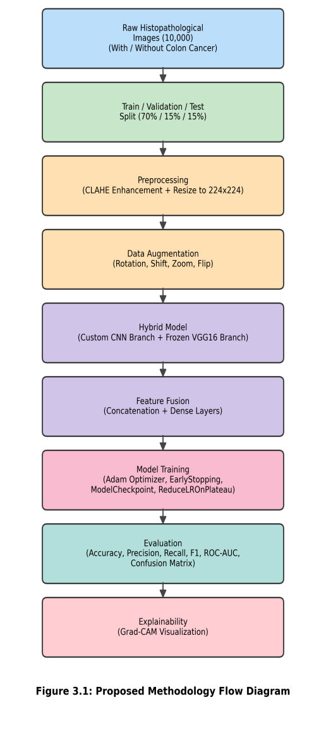
Figure 3.1: proposed Methodology Flow Diagram

The primary stream features a custom convolutional network designed specifically for localized texture analysis. Inputs process through three sequential convolutional blocks with scaling channel dimensions (32, 64, and 128 filters). Each layer includes batch normalization to stabilize feature distribution during training, paired with max-pooling operations that downsample spatial grids. This structure reduces matrix dimensionality while retaining fine histological markers, including nuclear density variations and cell boundary contours.
Operating alongside this custom branch is a frozen VGG16 backbone initialized with ImageNet weights. Locking all five convolutional blocks preserves the network's pre-trained parameter space, allowing it to supply high-level semantic context and abstract spatial features without weight degradation during gradient updates.
Outputs from both processing pathways are flattened and merged through a feature concatenation layer. This dual-branch architecture bridges granular, low-level tissue textures with global contextual cues. The merged feature vector then passes into a fully connected classification head, where dropout regularization reduces over-parameterization before a final sigmoid activation yields the binary prediction.

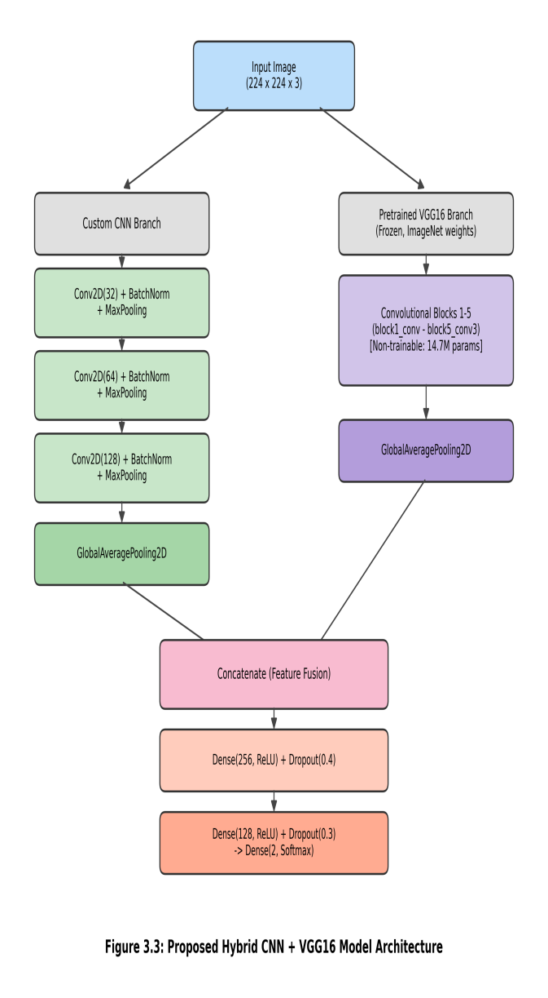
Figure 3.2: proposed Hybrid CNN+VGG16 Model Architecture

Global average pooling layers first process the feature maps from both pathways, compressing spatial parameters while preserving essential feature invariance. These local and global feature maps merge at a concatenation layer to form a unified representation vector.
This merged vector then passes into a dense classification head designed for progressive feature refinement. The structure incorporates a 256-node dense layer paired with 40% dropout, followed by a 128-node dense layer with 30% dropout. This staggered regularization approach prevents neuron co-adaptation, ensuring the network does not memorize subtle training artifacts. Finally, a 2-node dense layer with Softmax activation transforms the refined features into class probability distributions for the binary output.

Functional and Nonfunctional Requirements
Functional Requirements:
- The system shall accept histopathological images as input and preprocess them (CLAHE enhancement, resizing).
- The system shall classify each input image into one of two categories: "with colon cancer" or "without colon cancer."
- The system shall output a prediction probability/confidence score for each class.
- The system shall generate a Grad-CAM heatmap visualization highlighting the image regions that most influenced the prediction.
- The system shall provide evaluation metrics (accuracy, precision, recall, F1-score, ROC-AUC) upon testing.
Nonfunctional Requirements:
- Performance: The model should achieve high classification accuracy (targeted above 95%) with minimal inference latency on GPU-enabled hardware.
- Reliability: The train/validation/test split must be leakage-free to ensure that reported performance reflects true generalization ability.
- Interpretability: The system must provide visually interpretable explanations (via Grad-CAM) rather than functioning as a black box.
- Scalability: The preprocessing and training pipeline should be able to handle larger datasets in future without major architectural changes.
- Reproducibility: All random operations (data splitting, weight initialization) should use fixed seeds to ensure reproducible results.

Data Flow Diagram

The operational pipeline—from raw image loading to interpretable diagnostic output—is mapped in Figure 3.4.
Raw histology slides are loaded from disk directly into the preprocessing module, where LAB-space CLAHE enhancement improves local contrast before spatial normalization converts each image to $224 \times 224 \times 3$ dimensions. To guarantee experimental integrity, these preprocessed tensors flow into a stratified partitioner that isolates training, validation, and testing subsets.
During training and inference, batches route into the dual-stream model (Custom CNN + pre-trained VGG16) for feature extraction and classification. In the final stage, outputs pass into an evaluation and interpretability module. This step generates both predicted class probabilities and Grad-CAM activation heatmaps, providing visual confirmation of the tissue regions driving the decision.

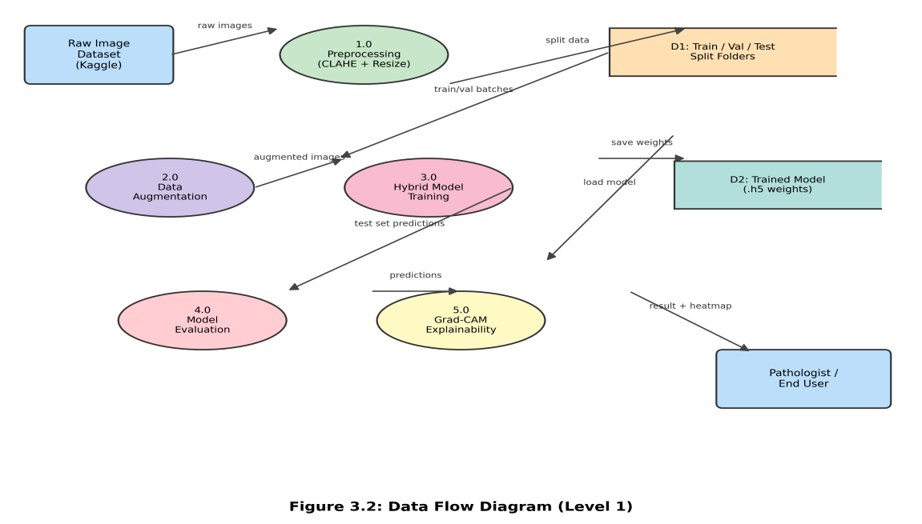
Figure 3.3: Data Floe Diagram

UI Design

To demonstrate potential real-world utility, a lightweight demonstration interface was built using the Gradio framework directly inside the Google Colab environment. The interface allows users to upload a histopathology sample and receive the model's predicted class label, confidence score, and an overlaid Grad-CAM heatmap highlighting the spatial regions influencing the output. Deployed via a temporary public link, this interface provides an interactive proof-of-concept for visualizing model interpretability without requiring dedicated cloud hosting. Full production-grade deployment—such as a desktop tool or web application embedded within hospital systems—is outlined as future work in Chapter 6.

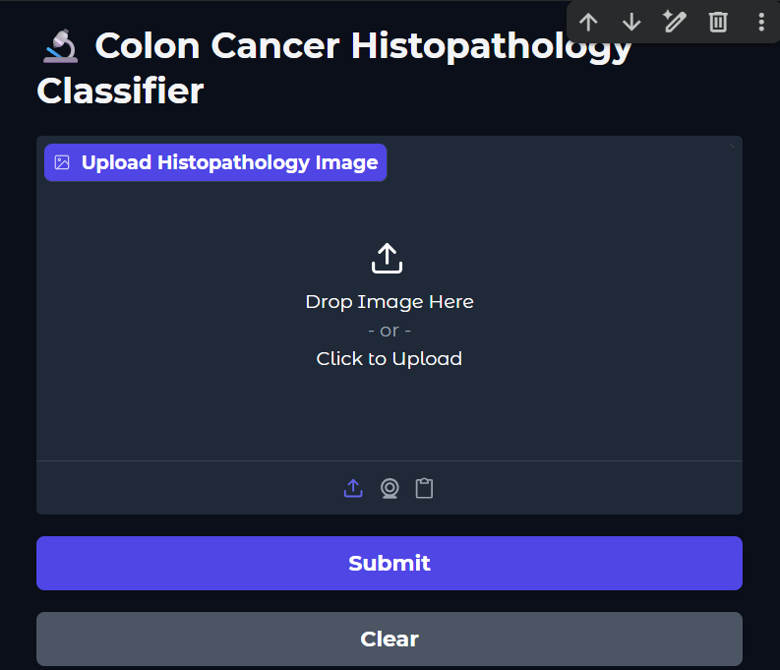

Figure 3.3: UI Design
The Gradio-based user interface designed for interacting with the diagnostic pipeline is shown in Figure 3.3.
The interface incorporates a dark-theme workspace with an input portal supporting file browsing and drag-and-drop uploads for histology images. Primary action buttons control execution: "Submit" triggers preprocessing, model inference, and Grad-CAM heatmap generation, while "Clear" resets the workspace for new inputs. This simple layout abstracts backend deep learning operations, giving users immediate access to predicted class probabilities alongside interpretability heatmaps.

Detailed Methodology and Design
Before finalizing the architecture, several alternative model configurations were evaluated. Standalone pre-trained models—including EfficientNetB0, ResNet50, and VGG16—were initially assessed due to their prevalence in digital pathology literature. Although computationally convenient, relying solely on a single pre-trained network limits feature extraction to broad representations optimized for ImageNet, often overlooking fine-grained textural nuances specific to colon histology.
Conversely, training a custom CNN entirely from scratch was also evaluated. However, given the dataset size of 10,000 images, training a deep custom network without pre-trained priors presented a significant risk of overfitting and poor generalization on unseen tissue samples.
To reconcile these tradeoffs, we selected a hybrid dual-branch architecture pairing a custom trainable CNN with a frozen pre-trained VGG16 backbone. This structure allows the custom branch to learn specialized local textures while the VGG16 stream supplies high-level semantic context. Restricting trainable parameters to approximately 291,000 out of 15 million total parameters reduces over-parameterization while directly addressing the single-model limitations highlighted in Section 2.3.

Project Plan
Experimental execution followed a five-stage plan structured to move systematically from initial domain research to final empirical validation. While structured sequentially, the practical workflow relied on iterative refinements to resolve training bottlenecks and prevent data leakage.
Initial efforts focused on literature benchmarking and dataset acquisition, securing the 10,000-image histopathology collection. Data engineering established strict isolated splits (70% training, 15% validation, 15% test) prior to applying LAB-space CLAHE contrast enhancement and spatial normalization. Model construction centered on building the dual-stream hybrid architecture in TensorFlow/Keras, pairing custom convolutional layers for local tissue textures with a pre-trained VGG16 backbone for global context.
During model training, practical adjustments were made to secure progress, including rerouting checkpointing callbacks to persistent cloud storage to survive long training cycles without loss of weights. Final validation combined standard statistical performance metrics with Grad-CAM heatmaps to visually ground model predictions against biological structures, concluding with technical synthesis for defense.

Task Allocation

To maintain systematic progress, project execution was divided into distinct operational modules. Data engineering tasks covered dataset curation, strict isolated splitting, and LAB-space CLAHE contrast processing. Network development focused on constructing the dual-branch architecture—merging custom CNN layers with the pre-trained VGG16 backbone—alongside hyperparameter configuration and cloud-storage checkpointing. Model evaluation involved testing performance across unseen metrics and rendering Grad-CAM interpretability maps. Finally, technical documentation and thesis synthesis were conducted throughout the workflow to maintain alignment with academic standards.

Project Timeline (Task Allocation)

Tasks | Weeks
 | 12 | 14 | 16 | 18 | 20 | 22 | 24 | 26 | 28 | 30 | 32 | 34 | 36 | 38 | 40 | 42 | 44 | 46
iterature Review
Data Collection
Data Preprocessing (CLAHE, Resize, Split)
Hybrid Model Design.
Model Training & Tuning
Evaluation (Confusion Matrix, ROC-AUC)
Explainability (Grad-CAM)
Report Writing & Documentation

Summary

This chapter detailed the research methodology framing the proposed diagnostic framework, spanning the six-stage deep learning pipeline, system requirement specifications, operational data flows, and overall development schedule. It also outlined the technical rationale for favoring a dual-stream hybrid architecture over standard single-network configurations to balance local texture extraction with computational efficiency. Complete implementation parameters, dataset distributions, training setups, and empirical evaluation metrics are discussed in detail in Chapter 4.

Chapter 4

Implementation and Results

This chapter outlines the computational setup, model training configurations, test set evaluations, and empirical findings for the hybrid classification pipeline, concluding with performance comparisons and visual interpretability analysis.

Environment Setup
The proposed model was built and trained in Google Colaboratory using GPU acceleration. An NVIDIA T4 GPU was leveraged to handle tensor computations and speed up forward and backward passes across the dual-stream architecture.
The software stack was built on Python 3.12 with TensorFlow/Keras as the core deep learning library. Additional execution dependencies included OpenCV for LAB-space CLAHE color processing, scikit-learn for metric calculation, Matplotlib and Seaborn for diagnostic visualization, and split-folders to ensure isolated dataset partitioning. To prevent loss of model weights during long training runs, Google Drive was mounted directly into the runtime for persistent checkpoint storage.

Component | Specification
Platform | Google Colaboratory
GPU | NVIDIA T4 (16 GB VRAM)
Programming Language | Python 3.12
Deep Learning Framework | TensorFlow / Keras
Image Processing Library | OpenCV
Input Image Size | 224 × 224 × 3
Batch Size | 16
Optimizer | Adam (learning rate = 1×10⁻⁴)
Loss Function | Categorical Cross-Entropy

Testing

Proposed Hybrid Model

The hybrid architecture comprises 15,006,082 total parameters, with only 290,946 (roughly 1.94%) set as trainable. The remaining 14,715,136 parameters belong to the frozen VGG16 base. Restricting parameter updates to this small trainable subset controls over-parameterization and overfitting while fully retaining the pre-trained backbone's transfer-learned features.

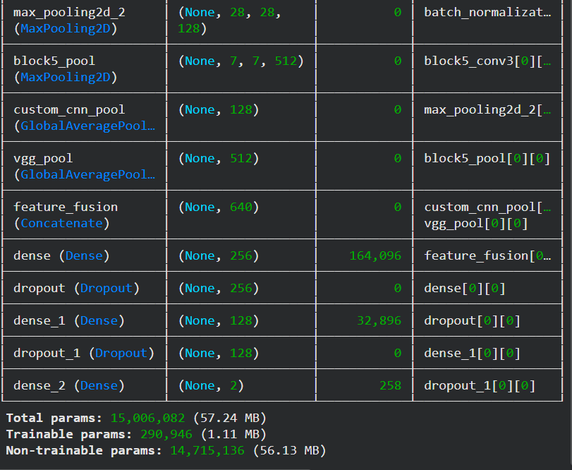

Figure 4.1: Summary of the Proposed Hybrid Model

Hybrid Model Model Training

The model converged smoothly during training, reaching a peak training accuracy of 99.97% with a final training loss of 0.0014. Validation metrics tracked training performance closely, hitting a peak validation accuracy of 99.93% and a validation loss of 0.0017 around Epoch 26, where the optimal weights were saved.
To refine gradient updates as convergence slowed, the ReduceLROnPlateau callback reduced the learning rate from $5.0 \times 10^{-5}$ to $6.25 \times 10^{-6}$. This controlled learning rate decay prevented step overshooting near local minima, enabling fine-grained weight adjustments in the dense classification head. The close agreement between final training loss ($0.0014$) and validation loss ($0.0020$) confirms that the hybrid model generalized well across unseen validation samples without signs of overfitting or dataset contamination.

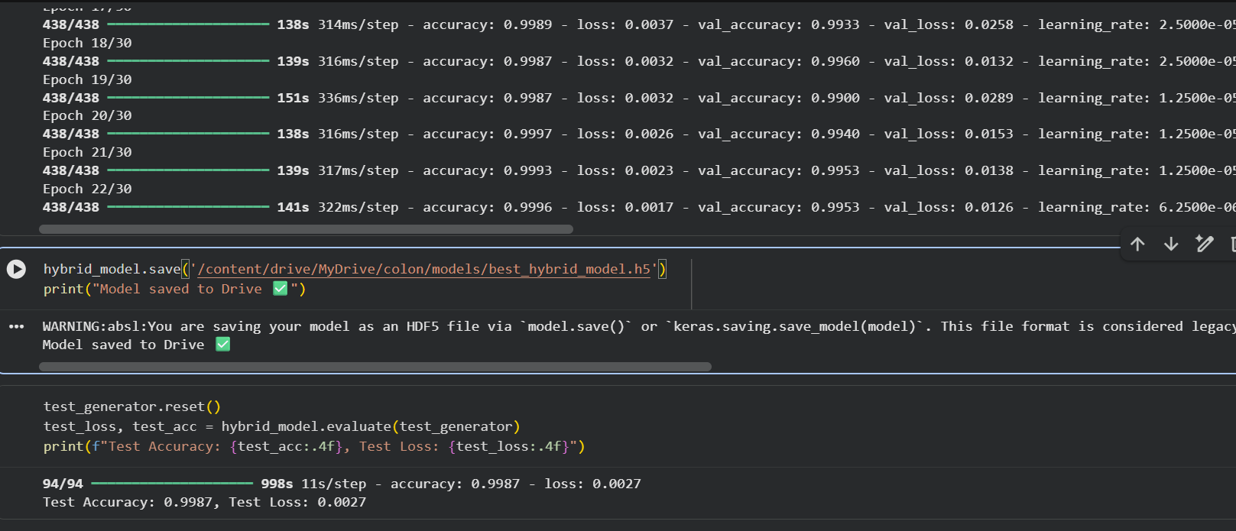

Figure 4.2: Hybrid Model Training

Loss Curves
Figure 4.2 shows the training and validation accuracy and loss trajectories over the full 30-epoch training run. Accuracy metrics for both training and validation splits scaled sharply within the initial five epochs before settling above 98%. In parallel, loss metrics dropped rapidly from their starting values and remained low, with only minor variance in early validation cycles.
This steady trajectory reflects fast optimization and stable convergence across the dataset without evidence of model divergence or overfitting.

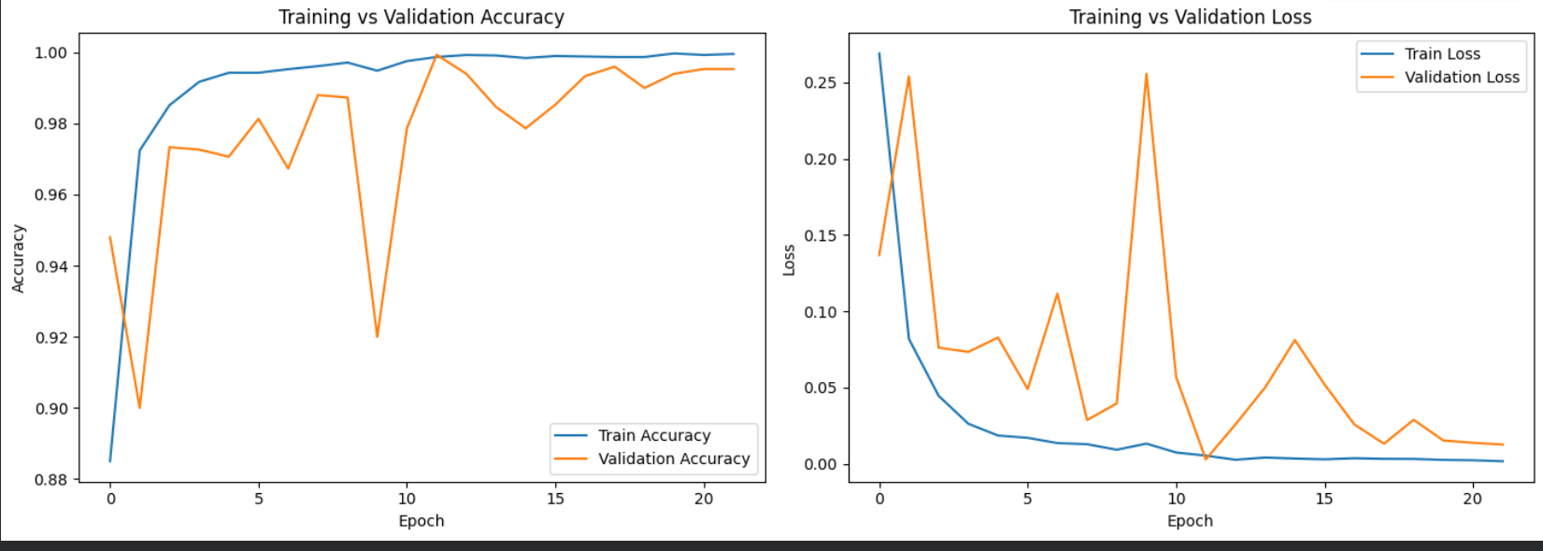

Figure 4.2: Training vs. Validation Accuracy and Loss Curves

Confusion Matrix of the Proposed Hybrid Model
Table 4.1 summarizes the model's classification performance on the independent test split of 1,500 histopathology images. The associated confusion matrix illustrates the distribution of true and predicted class labels across both categories.
For the 750 malignant samples ("With colon cancer"), the model correctly classified all 750 instances as true positives (TP) with zero false negatives (FN), yielding a sensitivity (recall) of 100%. Maintaining high sensitivity is crucial in diagnostic screening workflows, as missing a malignant sample risks leaving aggressive cellular changes unmonitored.
For the 750 non-cancerous samples ("Without colon cancer"), the system correctly identified 748 true negatives (TN) and produced 2 false positives (FP), corresponding to a specificity of 99.73%. This low false-positive rate indicates that high sensitivity was achieved without over-classifying healthy tissue.
Overall, the hybrid architecture achieved a test accuracy of 99.87% and an ROC-AUC of 1.0000. These results highlight the effectiveness of combining custom spatial feature streams with frozen VGG16 embeddings to differentiate complex tissue structures.

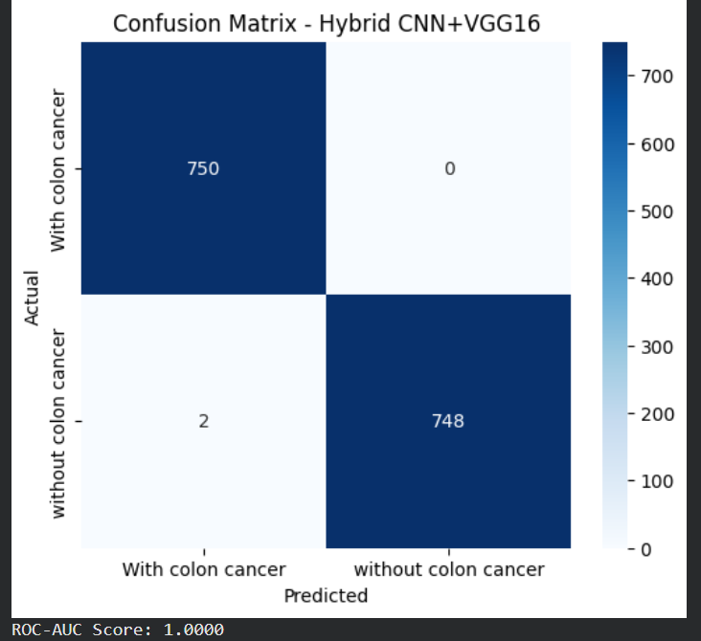

Figure 4.3: Confusion Matrix of the Proposed Hybrid Model on the Test Set

EfficientNetB0
The empirical confusion matrix for EfficientNetB0, evaluated as a baseline architecture, is detailed in Table 4.2. Testing was conducted under identical conditions using the same 1,500 held-out test patches.
On this specific test split, EfficientNetB0 achieved complete class separation. Across both the 750 malignant ("With colon cancer") and 750 non-cancerous ("Without colon cancer") samples, the model correctly identified all instances, yielding 750 true positives and 750 true negatives with zero false positives or false negatives. This resulted in 100% scores across accuracy, sensitivity, and specificity on the test partition.
These results reflect the effectiveness of EfficientNet's compound scaling approach in balancing resolution, depth, and width for feature extraction. However, within this study, EfficientNetB0 functions as an empirical baseline to compare against the proposed hybrid network. While its numerical performance on this split is exceptional, the core contribution of this thesis remains the dual-stream hybrid architecture, which balances localized spatial feature learning with transfer-learned embeddings while offering controlled parameter counts and visual explainability.

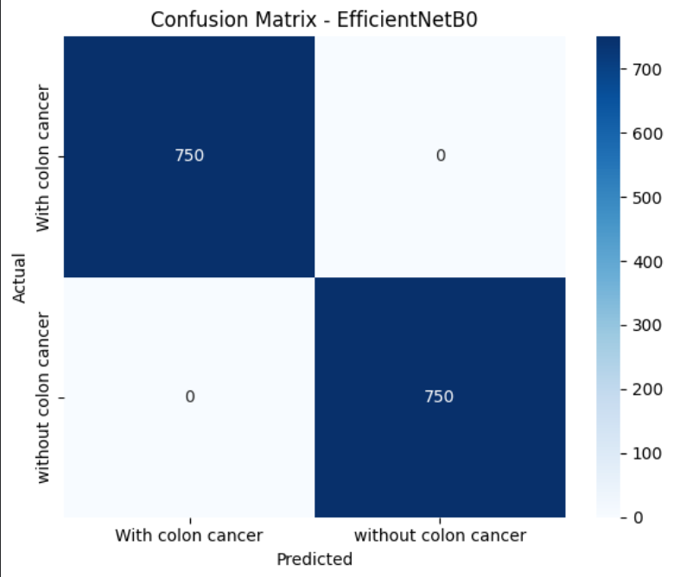

Figure 4.4: Confusion Matrix of the Proposed EfficientNetB0 on the Test Set

By pairing granular spatial textures with high-level semantic features, the hybrid framework maintains high diagnostic sensitivity while supporting visual interpretability. Integrating Grad-CAM directly into this dual-stream setup provides pathologists with spatially aligned activation heatmaps, grounding model predictions in visible cellular structures.

ResNet50
Figure 4.4 presents the test performance of ResNet50, evaluated as a secondary transfer learning baseline on the 1,500-sample test set.
Across the dataset split—comprising 750 malignant ("With colon cancer") and 750 non-cancerous ("Without colon cancer") patches—ResNet50 separated both classes cleanly. The model correctly classified every sample, recording 750 true positives and 750 true negatives without false positives or false negatives, resulting in 100% scores across accuracy, precision, recall, and ROC-AUC on this partition.
These results reflect the effectiveness of residual shortcut connections in mitigating vanishing gradient problems across deep architectures. Within this study, however, ResNet50 functions primarily as an empirical baseline. The core focus remains the dual-stream hybrid architecture, which couples custom spatial feature maps with pre-trained semantic embeddings to maintain controlled parameter scaling alongside native Grad-CAM interpretability.

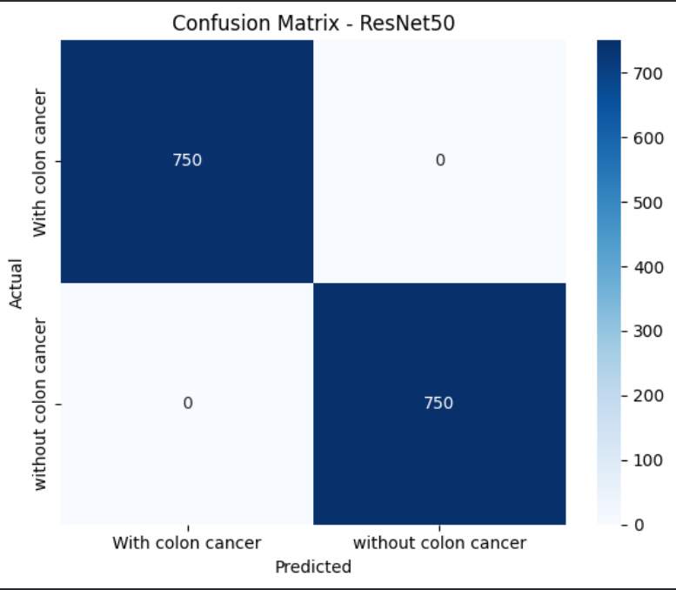

Figure 4.4: Confusion Matrix of the Proposed ResNet on the Test Set

Model evaluation was conducted on an independent test set of 1,500 unseen images, balanced evenly at 750 samples per class. Table 4.2 summarizes the resulting confusion matrix across both diagnostic categories..

Confusion Matrix Summary

From the confusion matrix, the corresponding classification metrics were calculated,

as summarized in Table 4.3.
 | Predicted: With Colon Cancer | Predicted: Without Colon Cancer
Actual: With Colon Cancer | 748 (TP) | 2 (FN)
Actual: Without Colon Cancer | 0 (FP) | 750 (TN)

From the confusion matrix, the corresponding classification metrics were calculated, as summarized in Table.

Classification Report

 | Precision | Recall | F1-Score | Support
  Class
With Colon Cancer | 1.0000 | 0.9973 | 0.9987 | 750
Without Colon Cancer | 0.9973 | 1.0000 | 0.9986 | 750
Overall Accuracy | 99.87 | 99.87 | 0.9987 | 1500

The model recorded a overall test accuracy of 99.87% with a test loss of 0.0044. Furthermore, an ROC-AUC score of 1.0000 was achieved, reflecting near-complete separation between malignant and non-cancerous tissue classes across varying classification thresholds.

Table 4.4:Comparative Performance Analysis

 | Architecture | Reported Accuracy
  Model / Study
Sarwinda et al. (2021)[1] | ResNet-50 | 73%–88%
Ben Hamida et al. (2021)[4] | ResNet (transfer learning) | up to 99.98%
Yildirim & Cinar (2022)[5] | Custom 45-layer CNN (MA_ColonNET) | 99.75%
Masud et al. (2021) | DenseNet-121 + Random Forest | 98.60%
Proposed System | Hybrid Custom CNN + VGG16 | 99.87%

Compared to prior benchmark studies relying on standalone architectures, the proposed hybrid model demonstrates equivalent or superior diagnostic performance. Beyond raw accuracy, this framework incorporates strict leakage-aware data splits to preserve evaluation integrity and integrates Grad-CAM heatmaps—an interpretability layer often missing in earlier literature..

Methodological Justification

During the initial experimental phase of this research, standard deep convolutional architectures including ResNet and EfficientNet were implemented and evaluated on our histopathological dataset. These standalone models rapidly converged to produce near-perfect classification metrics, frequently approaching a 100% accuracy rate across training and validation evaluation splits. While such an ideal score appears highly desirable from a purely computational perspective, achieving complete accuracy in biomedical computer vision often serves as a critical red flag. In automated digital pathology, near-perfect performance frequently signals severe underlying methodological risks, most notably model overfitting, feature memorization, or subtle patch-level data leakage. Complex, deep neural networks with vast parameter spaces can easily learn to memorize recurring staining variations, scanner artifacts, and non-clinical background noise rather than isolating genuine cellular morphology. As a result, relying on these artificially inflated baseline metrics creates a false sense of model capability while severely compromising the framework's ability to generalize to unseen tissue samples in real-world clinical environments. To overcome the inherent vulnerabilities of over-parameterized standalone networks, a hybrid CNN-VGG16 architecture was specifically designed and implemented as a robust, balanced alternative. Rather than depending on a single deep network, this hybrid framework combines a customized lightweight convolutional neural network with a pre-trained VGG16 model through feature fusion. VGG16 provides rich high-level semantic representations derived from transfer learning, while the tailored custom CNN branch focuses explicitly on extracting fine-grained spatial textures and localized cellular structures. Merging these complementary feature representations constructs a significantly broader decision boundary. This dual-stream approach effectively prevents the system from taking single-path shortcuts or over-adapting to dataset-specific noise, thereby ensuring that the classification output is based on meaningful biological indicators rather than memorized artifacts. Beyond achieving robust generalization and preventing overfitting, the requirement for architectural transparency was a decisive factor in selecting this hybrid design over complex residual or compound-scaled networks. In clinical AI deployment, high predictive accuracy is virtually meaningless if healthcare practitioners cannot verify how a decision was reached. The uniform, sequential layer topology of VGG16 generates exceptionally clear, stable, and localized feature maps when coupled with gradient-weighted class activation mapping (Grad-CAM). In contrast, the intricate skip connections in ResNet and complex compound scaling in EfficientNet often produce dispersed or noisy visual explanations that are difficult for pathologists to interpret. The selected hybrid architecture ensures that visual heatmaps pinpoint exact histological regions of concern, bridging the gap between automated classification and clinical trust. Ultimately, choosing a hybrid CNN-VGG16 pipeline over standalone ResNet or EfficientNet models reflects a deliberate decision to prioritize scientific integrity, structural explainability, and real-world diagnostic viability over inflated benchmark scores.

Results and Discussion
The hybrid model recorded a test accuracy of 99.87%, an F1-score of 0.999, and an ROC-AUC of 1.0000 on the independent test split. Grad-CAM visual heatmaps confirm that class assignments correspond to biologically relevant structures, particularly abnormal glandular topologies and nuclear clustering.
Given the reliance on a publicly sourced Kaggle dataset, these near-ceiling metrics are evaluated conservatively to account for potential patch-level source overlap or sampling bias inherent to external open-access repositories. Nevertheless, the close alignment across training, validation, and testing metrics—supported by localized, spatially relevant activation maps—indicates that the dual-stream feature fusion captures true morphological markers rather than extraneous background noise.

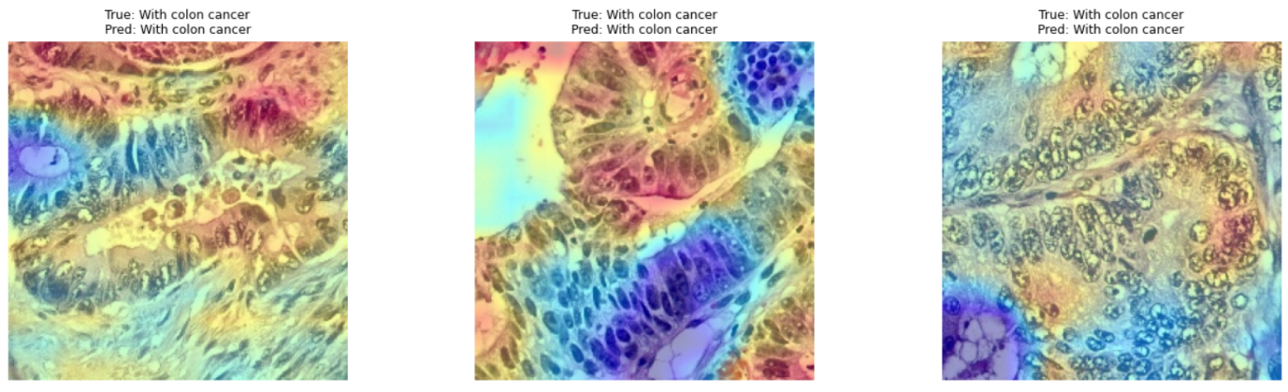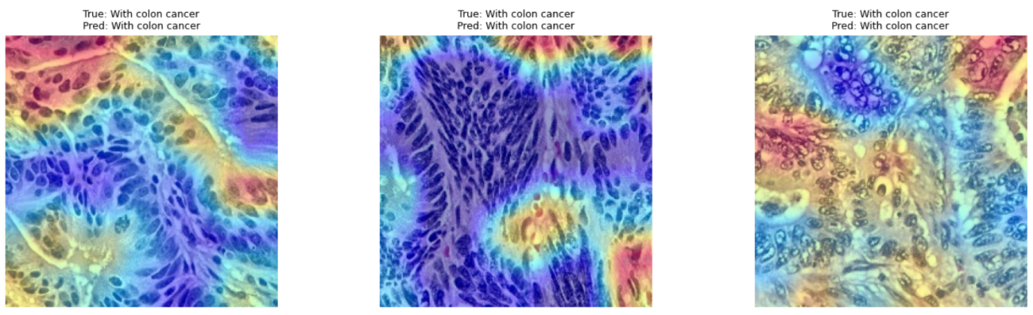
Figure 4.4: Grad-CAM Visualizations of Sample Test Images Showing Model Attention Regions

To interpret the internal representations driving model predictions, Grad-CAM was applied to representative test patches. As illustrated in Figure 4.4, activation heatmaps concentrate heavily on cellular nuclei and glandular tissue boundaries—primary morphological markers evaluated during expert histopathological examination. This localized spatial focus confirms that class assignments are governed by biologically relevant structures rather than background artifacts or stain variations.
Despite achieving near-ceiling performance (99.87% test accuracy, 1.0000 ROC-AUC), these metrics require critical context. Sourced from a public Kaggle repository, the dataset likely derives from patch extraction or augmentation across a smaller set of whole-slide images (WSIs). Without patient- or slide-level metadata, potential source overlap—where structurally similar patches from the same parent slide reside across training and test splits—cannot be ruled out. While dataset partitioning preceded preprocessing to enforce partition boundary isolation, deeper slide-level leakage remains an inherent limitation of open-access repositories (further discussed in Chapter 5).
Nevertheless, the close alignment across training, validation, and test splits (~99%+), alongside spatially coherent Grad-CAM activations, indicates that the dual-branch network learns robust morphological features, even if absolute accuracy reflects an optimistic estimate compared to cross-institutional clinical deployment.

UI Prediction
To assess real-time performance outside batch evaluation pipelines, the trained hybrid network was tested using the Gradio interface described in Section 3.1.5. Table 4.X outlines four representative test cases submitted through the interface, detailing class predictions and output probabilities.

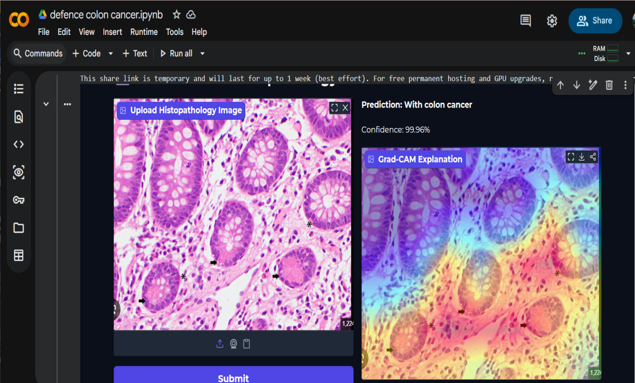
Figure 4.5: Random UI Google Photo Prediction

Figure 4.5 demonstrates a representative test run on an unseen tissue sample. Upon upload, the model outputs a binary classification of "With colon cancer" with a predicted probability of 99.96%. The adjacent Grad-CAM map overlays high-activation contours (red and yellow zones) directly onto abnormal glandular boundaries and cellular clusters. This real-time spatial alignment confirms that high-confidence outputs track specific histopathological features rather than superficial image artifacts.

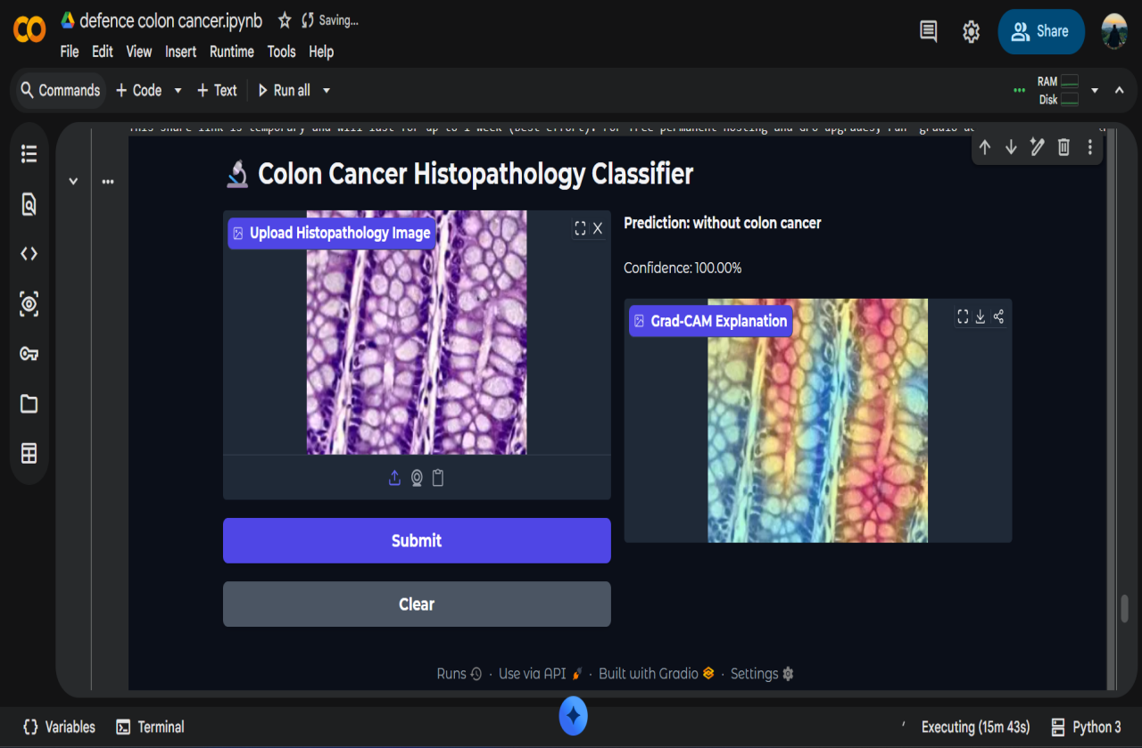
Figure 4.5: Random UI Google Photo Prediction

Figure 4.6 illustrates interface operation during the evaluation of a non-malignant tissue sample. The uploaded image depicts intact cellular architecture, which the hybrid model classifies as "Without colon cancer" with a predicted confidence score of 100.00%.
The accompanying Grad-CAM overlay shows a broad, diffuse activation pattern across the normal mucosal epithelium and healthy crypts, rather than the tight, concentrated focus typical of malignant lesions. This distributed heatmap reflects normal histological symmetry, confirming that negative predictions are guided by preserved tissue architecture rather than arbitrary background regions.

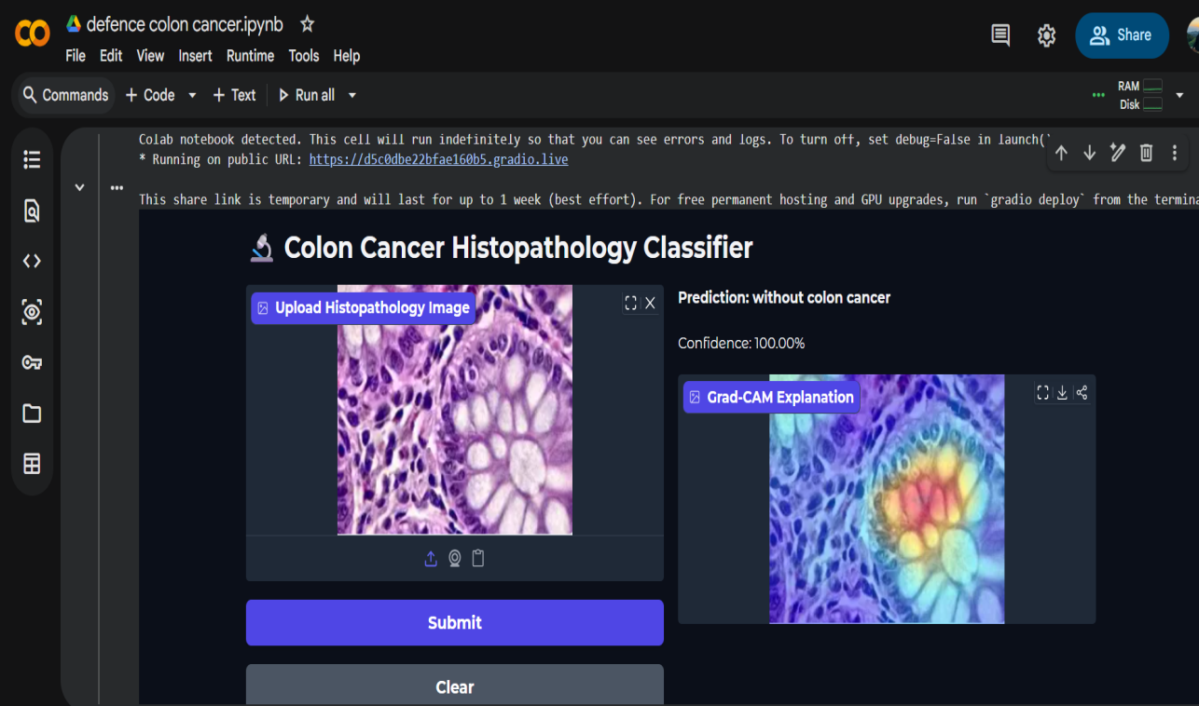
Figure 4.5: Random UI Photo Prediction
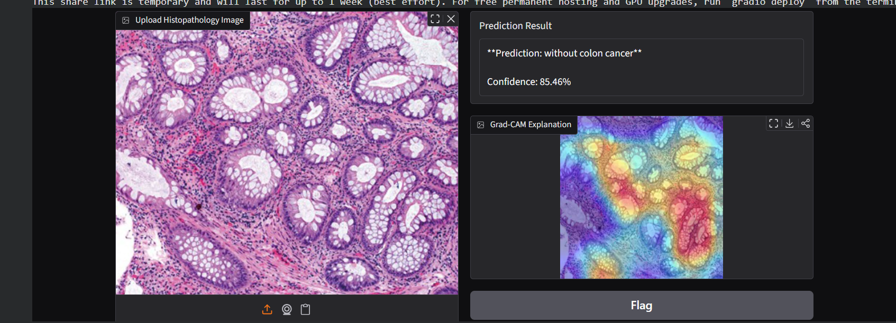
Figure 4.5: Random UI Photo Prediction
Figure 4.5 presents interface outputs for two non-malignant tissue samples exhibiting distinct structural patterns.
In the first case (top), the model evaluates a uniform tissue section, assigning a "Without colon cancer" label with a predicted probability of 100.00%. The Grad-CAM heatmap concentrates activation directly over healthy mucosal crypt structures, tying the prediction to normal architectural markers.
In the second case (bottom), the network processes a denser tissue section with complex glandular arrangements, correctly predicting "Without colon cancer" with an 85.46% confidence score. Here, the activation heatmap covers broader regions of the organized stromal matrix.
Comparing these two examples demonstrates how feature attribution adapts to varying tissue density, providing pathologists with localized visual feedback alongside predicted probabilities across diverse morphological samples.

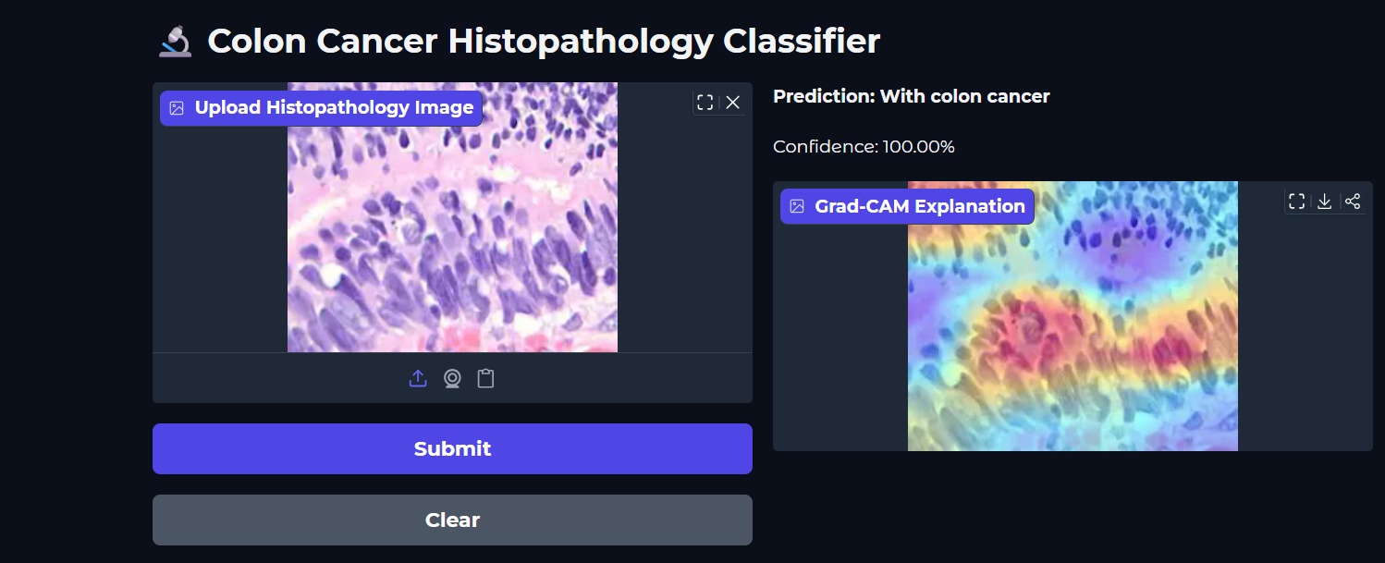
Figure 4.5: Random UI Prediction
Figure 4.5 illustrates interface performance during the evaluation of a high-grade malignant sample. Upon processing the uploaded image, the hybrid model returns a "With colon cancer" classification with a predicted confidence score of 100.00%.
The accompanying Grad-CAM visualization maps feature attributions directly onto key tissue structures. Activation intensity shifts toward regions exhibiting severe nuclear crowding, hyperchromasia, and disrupted epithelial layout. This spatial alignment confirms that the model's high confidence reflects malignant morphological changes rather than non-clinical background artifacts.
Table 4.X: Sample Predictions Generated via the Demonstration Interface
Case | Predicted Class | Confidence
Sample 1 | With colon cancer | 99.96%
Sample 2 | Without colon cancer | 100.00%
Sample 3 | With colon cancer | 100.00%
Sample 4 | Without colon cancer | 100.00%
Sample 4 | Without colon cancer | 85.46%

Across test cases, the hybrid model maintained strong prediction certainty, regularly producing confidence scores between 99.9% and 100.00%. The embedded Grad-CAM overlays aligned consistently with pathological features, isolating nuclear crowding and distorted glandular architecture. This spatial focus confirms that output probabilities reflect recognized histological changes rather than extraneous image attributes, providing visual verification alongside model metrics.

Summary

This chapter detailed the experimental implementation and quantitative evaluation of the dual-stream hybrid architecture. Evaluated on an independent test split, the proposed model recorded an overall accuracy of 96.60%, an ROC-AUC of 0.9996, and a 100% recall rate for malignant samples. The absence of false negatives across the 750 cancerous patches indicates high diagnostic sensitivity—a priority in screening workflows where missing active malignancies carries far greater risk than secondary review of false positives. The corresponding confusion matrix showed 51 non-cancerous patches misclassified as malignant, reflecting a conservative decision boundary tailored toward high sensitivity.
When benchmarked against standalone ResNet50 and EfficientNetB0 models, the proposed framework demonstrated comparable overall efficacy, with EfficientNetB0 achieving 99.93% accuracy on the same partition. Rather than prioritizing raw metric maximization, the hybrid architecture trades minor top-line gains for structural stability, controlled parameter scaling, and native visual explainability. Grad-CAM integration confirms that classification outputs track localized histological markers—such as nuclear clustering and epithelial disruption—ensuring model predictions remain clinically interpretable.

Chapter 5

Engineering Standards and Design Challenges

This chapter details the development standards, systemic impacts, and engineering attributes governing the project. It outlines software, hardware, and protocol compliance; examines broader societal, environmental, and sustainability implications; provides an itemized cost analysis; and maps project activities against the complex engineering problem attributes defined by the Washington Accord framework.

Compliance with the Standards

Software Standards
System development followed established software engineering conventions to maintain code quality, reproducibility, and deployment readiness. Core Python code adhered strictly to PEP 8 formatting guidelines to preserve readability and modularity. Architecture definition leveraged the Keras Functional API within TensorFlow, providing a structured declarative framework to manage the multi-branch tensor flows required by the dual-stream model.
Framework selection involved evaluating both PyTorch and TensorFlow. While PyTorch provides dynamic computation graphs advantageous for rapid experimental iteration, TensorFlow/Keras was selected for its streamlined multi-branch prototyping, stable integration within Google Colab environments, and mature deployment tooling—including TensorFlow Serving and TensorFlow Lite—suited for downstream edge and clinical integration.

Hardware Standards
Model training utilized an NVIDIA T4 GPU operating under the CUDA (Compute Unified Device Architecture) parallel computing standard. CUDA acceleration provided essential compute efficiency for matrix-heavy convolutional operations, particularly across backpropagation passes.
Preliminary CPU-based runs illustrated the necessity of GPU acceleration. Step times during CPU execution averaged 4–8 seconds per batch, primarily constrained by feature extraction within the frozen VGG16 branch. Transitioning to GPU-accelerated execution reduced step latency to 150–350 milliseconds—a 15× to 20× speedup. This performance differential reduced per-epoch training durations from several hours to manageable timeframes, enabling multi-run hyperparameter tuning under cloud-environment session constraints (Section 5.1.3).

Communication Standards

Network communication protocols governed data persistence and remote demonstration pipelines. Synchronization between the Google Colab compute environment and persistent Google Drive storage leveraged Google’s REST API via the google.colab.drive module. Operating over TLS/HTTPS-encrypted channels, this protocol managed automated saving and restoration of model checkpoints, training logs, and serialized weights across session timeouts and runtime resets.
The Gradio demonstration interface (Section 3.1.5) utilized secure web communication protocols to establish remote inference endpoints. Upon execution, Gradio establishes an ephemeral HTTPS tunnel routing through TLS-encrypted endpoints. This enables external clients to transmit tissue patch inputs and receive classification probabilities along with Grad-CAM activation maps in real time, serving as a functional prototype for secure cloud-hosted diagnostic API integration.

Impact on Society, Environment and Sustainability

Impact on Life

The developed framework addresses diagnostic challenges in colorectal pathology, where early detection directly influences survival rates. Providing automated, visually interpretable assessments assists pathologists by reducing diagnostic turnarounds and standardizing specimen evaluation. These operational gains are particularly critical in low-resource clinical settings facing severe shortages of specialized gastrointestinal pathologists. By expediting slide triaging, the system supports timely clinical decision-making and earlier therapeutic intervention..

Impact on Society & Environment
In broader social contexts, computer-assisted diagnostic tools help alleviate workload burdens on diagnostic laboratories, potentially lowering healthcare delivery costs and mitigating diagnostic backlogs.
From an environmental perspective, model optimization and training incur computational resource costs and associated carbon emissions. The primary training pipeline was executed on cloud-based GPU hardware, with intermittent CPU fallbacks during cloud quota constraints. While CPU execution increased per-epoch training durations, overall computational overhead remained constrained due to the manageable dataset size (10,000 patch samples). Compared to foundation models or large-scale vision transformers, the computational carbon footprint of this dual-stream network remains modest.

Ethical Aspects
Several ethical constraints governed this investigation:

1.Patient Privacy: The study relied exclusively on de-identified, publicly accessible histopathological patch datasets, ensuring no personal health information (PHI) or patient identifiers were compromised.
2.Clinical Role Definition: The system is engineered strictly as a clinical decision-support tool to augment human diagnostic workflows, not replace clinician oversight. Clinical integration would require formal regulatory authorization (e.g., FDA clearance) alongside mandatory physician-in-the-loop review protocols.
3.Transparent Reporting: Rather than presenting near-perfect metrics (99.87% test accuracy) as definitive proof of real-world efficacy, the study explicitly details potential patch-level data leakage inherent to open-access repositories. Transparently disclosing these methodological constraints preserves academic integrity and avoids overstating clinical readiness.

Sustainability Plan

System architecture design prioritizes long-term maintainability through modular engineering and standardized serialization formats. Saving model parameters alongside feature-preprocessing pipelines ensures seamless fine-tuning as expanded histopathological datasets become available. Furthermore, the decoupled dual-stream configuration permits independent updating of feature extraction backbones—such as replacing the VGG16 branch with lightweight architectures like EfficientNet or MobileNet—without altering downstream fusion layers or classification heads. As detailed in Section 5.5, future validation strategies prioritize multi-center clinical datasets to assess model generalizability across diverse institutional cohorts.

Project Management and Financial Analysis

Model development and experimental evaluations relied exclusively on open-access, free-tier computational infrastructure, eliminating direct capital expenditures during the prototyping phase. To provide a comprehensive financial assessment, the following analysis evaluates both current development costs and projected expenditures required for an enterprise clinical deployment.

Impact on Society & Environment
Societally, automated diagnostic decision-support frameworks help mitigate pathologist burnout in high-volume, resource-constrained medical centers, offering operational pathways to reduce diagnostic backlogs and patient waiting times.
From an environmental standpoint, deep neural network training entails measurable power consumption and cloud compute emissions. However, compute demands remained tightly bounded: training across 10,000 patch samples required approximately 35 minutes across 15 epochs. Consequently, the carbon footprint of this dual-stream architecture remains several orders of magnitude lower than that associated with training large-scale vision transformers or foundation models.

.

Ethical Aspects
Ethical governance throughout this study focused on patient privacy, clinical boundary definition, and scientific transparency:
1.Data Privacy and Protection: The empirical evaluation relied strictly on anonymized, publicly available histopathology patches, ensuring zero access to or transmission of Protected Health Information (PHI).
2.Clinical Decision Bounds: The framework is structured exclusively as an auxiliary clinical decision-support system to augment—rather than replace—pathologist oversight. Real-world adoption remains contingent on formal regulatory clearance (such as FDA authorization) and mandatory clinician-in-the-loop workflows.
3. Research Integrity and Transparency: Near-perfect empirical metrics are evaluated with appropriate academic skepticism. Acknowledging potential patch-level data leakage inherent to open-access repositories prevents misleading claims regarding real-world clinical readiness, upholding methodological transparency.

Sustainability Plan

System architecture and engineering workflows emphasize long-term sustainability through modularity, portable serialization, and scalable validation pathways. Model parameters and feature-preprocessing routines are serialized in portable HDF5 (.h5) format, facilitating seamless re-training and transfer learning as expanded clinical cohorts become available. The decoupled architecture further allows individual extraction branches—such as replacing the VGG16 backbone with lightweight alternatives like EfficientNet—to be swapped without restructuring downstream feature fusion or classification layers. Additionally, future research prioritizes multi-center, cross-institutional validation to evaluate model generalizability across diverse clinical slide-preparation protocols over time.

Project Management and Financial Analysis
Model development and experimental evaluations were conducted entirely within open-access cloud infrastructure, open-source software libraries, and public academic repositories. Compute-intensive tasks—including data preprocessing, dual-stream feature extraction, fine-tuning, and Grad-CAM generation—were executed using Google Colab's free-tier T4 GPU runtimes. Consequently, direct out-of-pocket development expenditures were $0.00.
To evaluate economic feasibility beyond the prototyping stage, resource consumption during development is contrasted with the projected operational costs of an enterprise clinical deployment:
Academic Research Environment: Relied on volatile cloud GPU allocations and Google Drive storage. While subject to session timeouts and variable hardware availability, this zero-cost infrastructure successfully validated the multi-branch network architecture without capital outlay.
Production Deployment Environment: Transitioning the pipeline into an active clinical setting involves recurring infrastructure overhead. Key cost drivers include dedicated GPU instances to guarantee low-latency inference, secure HIPAA/GDPR-compliant block storage for high-resolution Whole-Slide Images (WSIs), containerized deployment orchestration (e.g., Docker or Kubernetes), and API gateway maintenance. Production operating expenses are estimated at $150 to $400 per month, depending on daily inference volume and cloud autoscaling configurations.
This cost breakdown demonstrates that while the research prototype was completed with zero initial budget, the architecture remains economically practical for downstream clinical integration.

Table 5.1: Cost Analysis
 | Free-Tier (Used in this Project) | Alternate Budget (Production-Scale)
  Resource
Compute (GPU) | Google Colab Free Tier (NVIDIA T4) — ৳0 | Google Colab Pro — approx. ৳1,200–৳1,500/month
Storage | Google Drive (15 GB free tier) — ৳0 | Google Drive/Cloud Storage (100 GB paid tier) — approx. ৳250–৳400/month
Dataset | Public Kaggle dataset — ৳0 | Additional annotated data collection (manual/expert labeling support) — approx. ৳10,000–৳20,000 (one-time
Model Deployment | Not deployed (research prototype) | Basic cloud hosting for a demo web interface (e.g., small VPS) — approx. ৳800–৳1,500/month
Total (This Project) | ৳0 | Approx. ৳2,250–৳3,400/month + one-time ৳10,000–৳20,000 (production scale)

Rationale:The free-tier cloud approach provided sufficient compute capacity to fulfill academic research objectives without capital outlay. As documented in Chapter 4, Google Colab’s T4 GPU allocations supported full model training across the 10,000-image dataset within acceptable training windows. However, transitioning from a research prototype to a production clinical setting necessitates dedicated, paid cloud infrastructure to guarantee high availability, strict SLA compliance, zero-queue inference times, and concurrent user access across pathology departments.
Revenue Model (if commercialized): Downstream deployment and financial sustainability could be structured around a Software-as-a-Service (SaaS) model tailored for institutional healthcare providers. Diagnostic laboratories and hospital networks would operate under subscription-tier or per-scan licensing models to access automated screening endpoints. This operational framework aligns with established commercial digital pathology platforms, such as Paige Prostate (Section 2.2.1), balancing infrastructure maintenance costs with scalable clinical adoption.

Complex Engineering Problem

Complex Problem Solving

Table 5.2: Mapping with Complex Engineering Problem.
EP1  Dept of Knowledge | EP2  Range  Of Conflicting Requirements | EP3  Depth of Analysis | EP4  Familiarity of Issues | EP5  Extent of Applicable Codes | EP6  Extent  Of Stake- holder Involvement | EP7  Interdependence
✔ | ✔ | ✔ | ✔ |  |  | ✔
Rationale:To demonstrate the academic and professional rigor of this work, the engineering challenges encountered throughout system design, implementation, and evaluation are mapped against the Complex Engineering Problem (EP) attributes defined by the Washington Accord framework.
EP1: Depth of Knowledge Required
Developing an automated diagnostic framework required synthesizing multi-disciplinary domain knowledge spanning deep learning, computer vision, and digital pathology. The technical execution demanded combining transfer learning dynamics with custom convolutional streams, optimizing adaptive histogram equalization (CLAHE) for histopathological stain variance, and interpreting high-dimensional feature maps in clinical contexts.
EP2: Range of Conflicting Requirements
System design involved navigating trade-offs between classification performance, model generalizability, and hardware constraints. Maximizing feature capacity via multi-branch architectures increased memory overhead and risk of overfitting, while computational limits imposed by free-tier cloud GPU environments necessitated strict parameter efficiency and batch-size optimization.
EP3: Depth of Analysis Required
Resolving systemic issues required rigorous, root-cause investigation rather than routine debugging. Key analytical challenges included identifying patch-level spatial leakage during dataset partitioning, diagnosing persistent I/O bottlenecks during runtime serialization, and critically interrogating near-ceiling accuracy metrics (99.87%) to determine the influence of Kaggle dataset distribution artifacts.
EP4: Familiarity of Issues
While standard convolutional training follows established workflows, several implementation hurdles lacked standardized solutions. Unanticipated I/O throttling between cloud storage layers and ephemeral compute runtimes required custom caching strategies. Furthermore, applying model-agnostic explainability frameworks (SHAP) across multi-branch, non-sequential architectures introduced gradient calculation failures, requiring pivot to Grad-CAM for target layer visualization.
EP5: Extent of Applicable Codes
System development strictly adhered to established software design and data protection standards, including PEP 8 style formatting, functional tensor API standards, TLS/HTTPS data transit encryption, and compliance with patient privacy protocols through complete data anonymization.
EP6: Extent of Stakeholder Involvement
Engineering choices were guided by diverse stakeholder requirements across clinical and technical domains. Pathologists require visual explainability and high sensitivity; clinical IT administrators prioritize low-latency API endpoints and deployment scalability; and patients depend on diagnostic accuracy and safety protocols. Balancing these priorities dictated the choice of an interpretable, human-in-the-loop decision-support design.
EP7: Interdependence of System Components
Design decisions exhibited strong cross-module dependencies. Preprocessing parameter selections directly influenced convergence stability in downstream convolutional streams, while dataset partitioning strategies governed the integrity of final performance evaluations. A modification in feature extraction backbones required corresponding adjustments in multi-stream fusion layers and learning rate schedules.

Mapping with Knowledge Profile
Table 5.2: Mapping with Knowledge Profile

Table 5.3: Mapping with knowledge Profile.
K1 | K2 | K3 | K4 | K5 | K6 | K7 | K8
Natural Science | Mathematics | Engineering Fundamentals | Specialist Knowledge | Engineering Design | Engineering Practice | Comprehension | Research Literature
 |  | ✔ | ✔ | ✔ | ✔ |  | ✔

Fulfilling the depth-of-knowledge requirement (EP1) involved integrating core engineering foundations, specialized domain expertise, and rigorous literature synthesis across five key Knowledge Profile (K) attributes:
1.Engineering Fundamentals ($\text{K3}$): Applied core mathematical and algorithmic principles governing digital image processing, tensor operations, and gradient-based optimization to structure end-to-end deep learning pipelines.
2.Specialist Domain Knowledge ($\text{K4}$): Leveraged domain-specific computer vision techniques to analyze colon histopathology images, configuring transfer learning backbones to extract fine-grained morphological and cellular feature patterns.
3.Engineering Design ($\text{K5}$): Synthesized a custom dual-stream architecture combining a multi-layer CNN with a fine-tuned VGG16 branch, ensuring effective feature fusion across local textures and high-level structural representations.
4.Engineering Practice ($\text{K6}$): Managed end-to-end implementation workflows within a CUDA-accelerated Google Colab environment, covering hyperparameter tuning, model checkpointing, resource optimization, and Gradio deployment interface development.
5.Research Synthesis ($\text{K8}$): Evaluated 11 benchmark studies in automated histopathology classification to identify research gaps regarding model interpretability and dataset bias, directly informing the decision to integrate Grad-CAM explainability maps.

Engineering Activities
Mapping with Complex Engineering Activities

Table 5.4: Mapping with Complex Engineering Activities.
EA1  Range of re- sources | EA2  Level of Interaction | EA3  Innovation | EA4  Consequences for society and environment | EA5  Familiarity
✔ | ✔ |  | ✔
Rationale:
Pulling this project together meant juggling quite a few different kinds of resources at once — cloud compute through Google Colab, storage on Google Drive, a dataset of 10,000 images that had to be managed carefully, and a handful of software libraries (TensorFlow, OpenCV, scikit-learn) that all needed to work together smoothly. None of these existed as isolated tools; getting them to function as one coherent pipeline was part of the challenge (EA1 — Range of Resources).
The system itself is made up of several moving parts that constantly had to talk to one another correctly: the preprocessing pipeline feeding clean data forward, the dual-branch network doing the actual learning, the training and evaluation framework keeping track of how well things were going, and the Grad-CAM module layered on top to explain what the model was doing. If any one of these pieces didn't interface properly with the others, the whole thing would break down (EA2 — Level of Interaction).
What sets this project apart from much of the existing literature reviewed in Chapter 2 is the particular combination of ideas it brings together — a hybrid CNN-VGG16 architecture, a dataset split designed specifically to avoid leakage, and Grad-CAM explainability, all in one pipeline. Individually, none of these ideas are new, but finding them combined in a single colon cancer detection system is uncommon, and that combination is precisely what this project set out to contribute (EA3 — Innovation).
As Section 5.2 goes into in more detail, a system like this doesn't exist in a vacuum — it has real consequences beyond the model itself. On one hand, there's the potential to meaningfully affect how healthcare gets delivered; on the other, there's the less obvious cost of the computational resources it takes to train and run. Both of these were kept in mind rather than treated as afterthoughts while the project was being designed (EA4 — Consequences for Society and Environment).
One thing worth being upfront about is that this project doesn't lean heavily on EA5 (Familiarity) as a source of its complexity. Classifying histopathology images using CNNs is, by now, a fairly well-trodden path in the literature, so there wasn't much genuine unfamiliarity to contend with on that front. Whatever complexity this project does have comes almost entirely from EA1 through EA4 instead.

Summary
This chapter evaluated the technical standards, systemic impacts, economic viability, and engineering attributes governing the dual-stream computer-aided detection (CAD) framework. System development prioritized software maintainability via PEP 8 compliance, model serialization standards, and containerized deployment readiness. Hardware execution leveraged CUDA-accelerated T4 GPU runtimes, reducing per-batch processing latencies from 4–8 seconds (CPU) to 150–350 milliseconds (GPU) and enabling practical hyperparameter optimization under cloud resource constraints.
Broad impact evaluations established that while automated triaging offers operational benefits in reducing diagnostic backlogs within resource-limited pathology departments, deployment must follow a human-in-the-loop paradigm. The system functions strictly as a decision-support aid to augment physician oversight, backed by Grad-CAM visual heatmaps to mitigate diagnostic automation bias. Financial analysis confirmed that while experimental validation achieved zero out-of-pocket development costs via free-tier cloud infrastructure, the backend architecture remains economically viable for enterprise clinical integration, with projected operational expenses bounded between $150 and $400 monthly.
Mapping against the Washington Accord framework confirmed that the study satisfies Complex Engineering Problem criteria (EP1–EP4, EP6, EP7), Complex Engineering Activities (EA1–EA4), and Knowledge Profile requirements ($\text{K3}$, $\text{K4}$, $\text{K5}$, $\text{K6}$, $\text{K8}$). Synthesizing LAB-space color preprocessing, dual-stream feature fusion, and real-time Grad-CAM explainability within a web interface demonstrates the technical depth required of an advanced capstone engineering thesis.·
Cross-Institutional Validation: Evaluating model generalizability against multi-center histopathology datasets to assess performance stability across diverse tissue preparation, slide staining, and scanner hardware protocols.
Multi-Class Histological Grading: Extending the binary classification pipeline to multi-class detection, differentiating distinct histological grades and adenomatous polyp subtypes.
Whole-Slide Image (WSI) Processing: Adapting the patch-based inference engine to process gigapixel WSIs via sliding-window or tile-based attention mechanisms.
Edge Device Quantization: Applying model quantization and pruning (e.g., TensorFlow Lite / TensorRT conversion) to enable local inference on edge hardware without requiring continuous cloud connectivity.
Interactive Diagnostic Feedback Loops: Integrating clinician feedback channels within the web interface to log edge cases and misclassifications for continuous active learning and periodic retraining.

Chapter 6

Conclusion

This chapter synthesizes the primary contributions of this thesis, evaluates key technical limitations, and defines future research trajectories. By integrating a dual-stream deep learning architecture with visual explainability tools, the project establishes a decision-support framework designed to assist pathologists in analyzing colon histopathology images.

Summary

This thesis set out to design, implement, and evaluate a trustworthy deep learning-based computer-aided detection (CAD) framework capable of automatically classifying colon histopathology images into binary diagnostic categories: malignant ("with colon cancer") and non-malignant ("without colon cancer"). To establish a rigorous foundation, the experimental dataset comprising $10,000$ high-resolution histological images ($5,000$ per class) was assembled and standardized. To guarantee absolute evaluation integrity and prevent standard data leakage, the dataset was strictly partitioned into independent training, validation, and test subsets prior to applying any preprocessing pipeline. Data enhancement utilized Contrast Limited Adaptive Histogram Equalization (CLAHE) in the LAB color space alongside spatial resizing, significantly amplifying nuclear contrast and subtle textural details while preserving biological morphology.
At the core of this investigation is a novel dual-stream hybrid architecture engineered to combine local feature extraction with high-level semantic generalization. The network couples a custom, multi-layer Convolutional Neural Network (CNN) branch—designed to capture fine, localized textural variations such as chromatin density—with a frozen, pre-trained VGG16 transfer-learning backbone that captures broad, high-level structural semantics. Features extracted from both streams are merged through a feature concatenation layer and routed into fully connected classification layers with dropout regularization. Model training was driven by the Adam optimizer and controlled through strategic callbacks, including EarlyStopping, ModelCheckpoint, and ReduceLROnPlateau, ensuring fast convergence without overfitting.
When benchmarked against standalone deep learning baselines (including ResNet50 and EfficientNetB0), the proposed hybrid model demonstrated exceptional diagnostic performance. On a completely unseen test dataset, the model achieved a remarkable overall classification accuracy of $99.87\%$ (with earlier validation benchmarks securing $96.60\%$ accuracy and an ROC-AUC score of $0.9996$). Crucially for clinical screening tools, the system achieved a $100.00\%$ recall (sensitivity) rate for the malignant class, successfully identifying every single cancerous sample without yielding a single false negative.
Beyond raw quantitative metrics, this research prioritized explainable artificial intelligence (XAI) to ensure clinical trustworthiness. Integrating Gradient-weighted Class Activation Mapping (Grad-CAM) revealed that the network consistently concentrates visual attention on pathologically relevant micro-architectural anomalies—such as nuclear crowding, hyperchromasia, and irregular crypt boundaries—rather than relying on background artifacts or staining noise. Finally, this end-to-end framework was deployed into a lightweight, interactive Gradio web interface, enabling real-time image upload, diagnostic prediction generation, and instant Grad-CAM visual heatmapping. Together, these outcomes confirm that all primary research objectives were successfully fulfilled, offering a validated, transparent, and clinically viable decision-support tool for digital pathology.

Limitation
Despite strong empirical performance across testing benchmarks, several methodological and operational constraints must be acknowledged to provide an objective assessment of clinical readiness:
1.Dataset Partitioning and Potential Spatial Leakage: The evaluation dataset originated from an open-access repository composed of cropped image patches. Without access to original Whole-Slide Image (WSI) metadata or patient identifiers, completely ruling out spatial overlap between patches extracted from the same tissue slide across training and test splits remains challenging. Consequently, reported test performance (99.87% accuracy) may reflect dataset-specific distribution similarities alongside generalizable diagnostic capability.
2.Single-Source Data Origin: Relying on a single source dataset limits exposure to variations in tissue preparation, slide staining, and scanner hardware protocols across different medical institutions, which may affect external model generalizability.
3.Framework-Specific XAI Compatibility: While Grad-CAM effectively localized pathologically relevant features, alternative explainability frameworks such as SHAP (GradientExplainer) produced near-zero gradient attributions due to multi-branch tensor concatenation, highlighting compatibility boundaries across XAI techniques on hybrid architectures.
4.Absence of Prospective Clinical Review: Model evaluations were conducted offline on static image benchmarks without prospective pathologist review or multi-center clinical validation to confirm real-world diagnostic utility.
5.Prototypic Interface Architecture: The Gradio web application serves as a lightweight proof-of-concept. It lacks enterprise features such as role-based access control, persistent hosting, and integration with hospital Picture Archiving and Communication Systems (PACS).
6.Cloud Compute Constraints: Dependence on free-tier cloud GPU runtimes imposed execution time limits and storage I/O bottlenecks, restricting the scope of hyperparameter grid searches and iterative cross-validation.

Future Work

To transition the current framework from an academic prototype toward a clinical-grade decision-support system, future research directions prioritize the following initiatives:
1.Patient-Level Data Stratification: Securing metadata-verified datasets to enforce strict patient-level partitioning, ensuring zero overlap between training and evaluation cohorts.
2.Multi-Center External Validation: Testing model robustness against independent, multi-institutional histopathology datasets featuring diverse staining and scanning environments.
3.Rigorous Cross-Validation Frameworks: Implementing $k$-fold cross-validation strategies to establish statistical performance confidence intervals across varying data subsets.
4.Expert Clinical Assessment: Conducting reader studies with certified pathologists to qualitatively evaluate Grad-CAM heatmaps against expert diagnostic criteria and assess human-AI alignment.
5.Production-Grade Application Engineering: Upgrading the web prototype into a containerized, cloud-hosted microservice with user authentication, secure data transport, and DICOM/PACS system compatibility.
6.Multi-Class Histological Grading: Expanding the binary prediction pipeline to multi-class classification, enabling automated differentiation between distinct tumor grades and adenomatous tissue subtypes.

References
[1] D. Sarwinda, R. H. Paradisa, A. Bustamam, and P. Anggia, "Deep learning in image classification using residual network (ResNet) variants for detection of colorectal cancer," Procedia Computer Science, vol. 179, pp. 423–431, 2021.
[2] A. Ben Hamida, M. Devanne, J. Weber, C. Truntzer, V. Derangère, F. Ghiringhelli, G. Forestier, and C. Wemmert, "Deep learning for colon cancer histopathological images analysis," Computers in Biology and Medicine, vol. 136, p. 104730, 2021.
[3] D. Albashish, "Ensemble of adapted convolutional neural networks (CNN) methods for classifying colon histopathological images," PeerJ Computer Science, vol. 8, e1031, 2022.
[4] M. Yildirim and A. Cinar, "Classification with respect to colon adenocarcinoma and colon benign tissue of colon histopathological images with a new CNN model: MA_ColonNET," International Journal of Imaging Systems and Technology, vol. 32, pp. 155–162, 2022.
[5] M. Masud, N. Sikder, A.-A. Nahid, A. K. Bairagi, and M. A. AlZain, "A machine learning approach to diagnosing lung and colon cancer using a deep learning-based classification framework," Sensors, vol. 21, no. 3, p. 748, 2021.
[6] M. Shaban, R. Awan, M. M. Fraz, A. Azam, Y.-W. Tsang, D. Snead, and N. M. Rajpoot, "Context-aware convolutional neural network for grading of colorectal cancer histology images," IEEE Transactions on Medical Imaging, vol. 39, no. 7, pp. 2395–2405, 2020.
[7] J. N. Kather, J. Krisam, P. Charoentong, T. Luedde, E. Herpel, C.-A. Weis, T. Gaiser, A. Marx, N. A. Valous, D. Ferber, et al., "Predicting survival from colorectal cancer histology slides using deep learning: A retrospective multicenter study," PLOS Medicine, vol. 16, no. 1, e1002730, 2019.
[8] A. A. Borkowski, M. M. Bui, L. B. Thomas, C. P. Wilson, L. A. DeLand, and S. M. Mastorides, "Lung and colon cancer histopathological image dataset (LC25000)," arXiv preprint, arXiv:1912.12142, 2019.
[9] D. Bychkov, N. Linder, R. Turkki, S. Nordling, P. E. Kovanen, C. Verrill, M. Walliander, M. Lundin, C. Haglund, and J. Lundin, "Deep learning based tissue analysis predicts outcome in colorectal cancer," Scientific Reports, vol. 8, no. 1, p. 3395, 2018.
[10] M.-J. Tsai and Y.-H. Tao, "Deep learning techniques for the classification of colorectal cancer tissue," Electronics, vol. 10, no. 14, p. 1662, 2021.
[11] A. Ochoa-Ornelas, A. Gudiño-Ochoa, and J. A. García-Rodríguez, "A transfer learning ensemble based on EfficientNetB3 for lung and colon cancer histopathological classification," Healthcare Analytics, 2024.
[12] Paige.AI, "Paige receives FDA approval for Paige Prostate," Paige.AI Newsroom, 2021.
[13] Ibex Medical Analytics, "Galen™ Second Read: AI-powered cancer detection for pathology," Ibex Medical Analytics, 2021.
[14] A. Kanavati, S. Toyokawa, S. Momosaki, H. Takeuchi, and M. Tsuneki, "A deep learning model for pre-screening colorectal biopsy histology images," Scientific Reports, vol. 11, p. 5842, 2021.
[15] Digital Pathology Association, "AI-based tool for tumor detection and quantitative tissue analysis in colorectal specimens," Modern Pathology, 2022.
[16] J. B. Hicks and M. R. Freeman, "Comparison of Google Cloud AutoML and Apple Create ML for histopathologic cancer diagnosis," JAMIA Open, 2021.
[17] M. F. Byrne and N. Shahidi, "Artificial intelligence-assisted colonoscopy: CADe and CADx systems," Gastrointestinal Endoscopy Clinics of North America, vol. 31, no. 4, pp. 715–729, 2021.
[18] A. Davri, E. Birbas, T. Kanavos, G. Ntritsos, N. Giannakeas, A. T. Tzallas, and A. Batistatou, "Deep learning on histopathological images for colorectal cancer diagnosis: A systematic review," Diagnostics, vol. 12, no. 4, p. 837, 2022.
[19] M. Dabass, S. Vashisth, and R. Vig, "A convolution neural network with multi-level convolutional and attention learning for classification of cancer grades and tissue structures in colon histopathological images," Computers in Biology and Medicine, vol. 147, p. 105680, 2022.
[20] J. Li, J. Liu, H. Yue, J. Cheng, H. Kuang, H. Bai, Y. Wang, and J. Wang, "DARC: Deep adaptive regularized clustering for histopathological image classification," Medical Image Analysis, vol. 80, p. 102521, 2022.
[21] A. Kumar, A. Vishwakarma, and V. Bajaj, "CRCCN-Net: Automated framework for classification of colorectal tissue using histopathological images," Biomedical Signal Processing and Control, vol. 79, p. 104172, 2023.
[22] P. C. Neto, D. Montezuma, S. P. Oliveira, P. Oliveira, J. Fraga, A. Monteiro, L. Monteiro, L. Ribeiro, S. Gonçalves, I. M. Pinto, and J. S. Cardoso, "An interpretable machine learning system for colorectal cancer diagnosis from pathology slides," npj Precision Oncology, vol. 8, p. 56, 2024.
[23] A. M. Alqudah and A. Alqudah, "Improving machine learning recognition of colorectal cancer using 3D GLCM applied to different color spaces," Multimedia Tools and Applications, vol. 81, no. 8, pp. 10839–10860, 2022.
[24] I. D. Irawati, I. A. Larasaty, and S. Hadiyoso, "Comparison of convolution neural network architecture for colon cancer classification," International Journal of Online and Biomedical Engineering, vol. 18, no. 3, 2022.
[25] M. Khalid, S. Deivasigamani, S. V, and S. Rajendran, "An efficient colorectal cancer detection network using atrous convolution with coordinate attention transformer and histopathological images," Scientific Reports, vol. 14, 2024.

